React.js
- HTML
- CSS
- Javascript
HTML: It is mainly to display the content
CSS: It is to style the HTML
Javascript: It is to add effects to the web page by changing HTML & CSS at runtime

Software requirement
- VS Code
- Live server plugin: To auto-reload the changes and give a live preview

New Features of ES6 or Javascript
Template String literal:
It avoids you to break the string i.e., using + operator to concatenate string and the expression
var name = “…”;
var email = “…”;
`<h3>Your name is ${name}, email id ${email}</h3>`

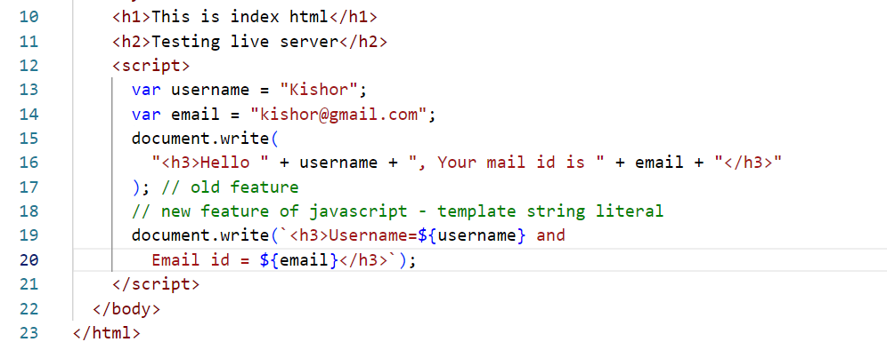

Classes & Constructors to create object
ES6 introduced class & constructor keyword to create the objects, earlier developers had to use functions as a constructor to create the object.
Old approach
function Employee(id, name, salary) {
this.id = id;
this.name = name;
this.salary = salary;
}
var obj = new Employee(123, “Raj”, 45000);
obj.id, obj.name, obj.salary will access the properties
Suppose you want to add a function to the object, then you must use prototype.
Employee.prototype.display = function() {
document.write(….);
}
obj.display();
New approach: ES6 introduced classes & constructors to simplify creating objects
class Employee {
constructor( id, name, salary) {
this.id = id;
this.name = name;
this.salary = salary;
}
display() {
document.write(….);
}
}
let obj = new Employee(2345, “Rajesh”, 42000);
obj.display();
example
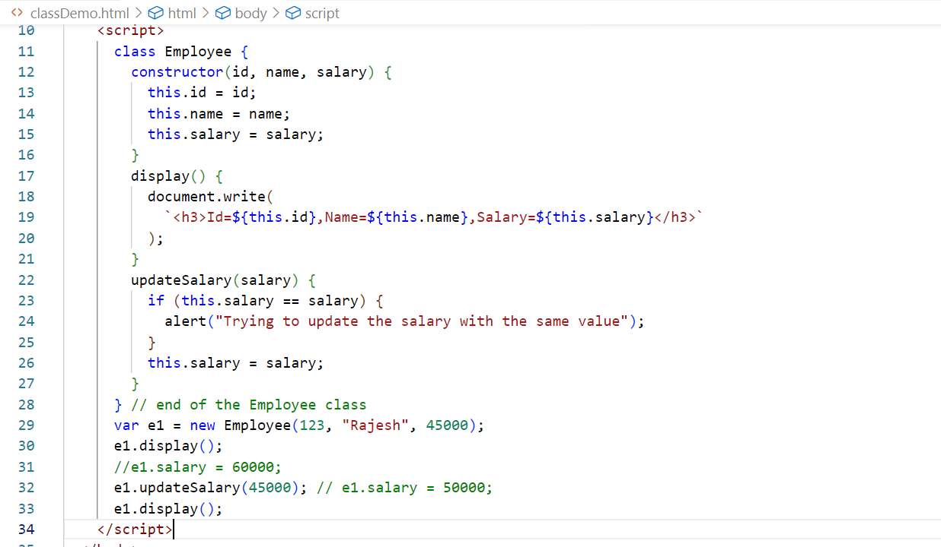
let & const keywords
They are used to create block scope variables, var was the keyword which was earlier used to create variables it is not a block scoped variable, it must be avoided
if(…) {
var cal = x + y;
let cal2 = x + y;
const cal3 = x + y;
}
you can access cal variable outside the if block
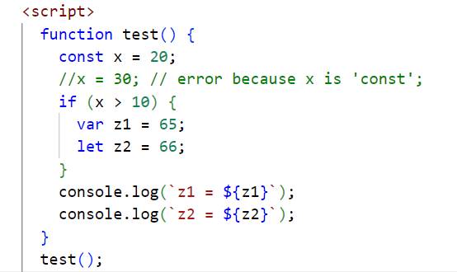

Event Handling: This was there even before ES6, it is used to detect the element generated the event & perform some action (executing some code)
In Javascript an event is referenced using an event property, list of events that an element can generate
- onsubmit
- onclick
- onmouseover
- onmouseout
- onfocus
- onblur
- onchange
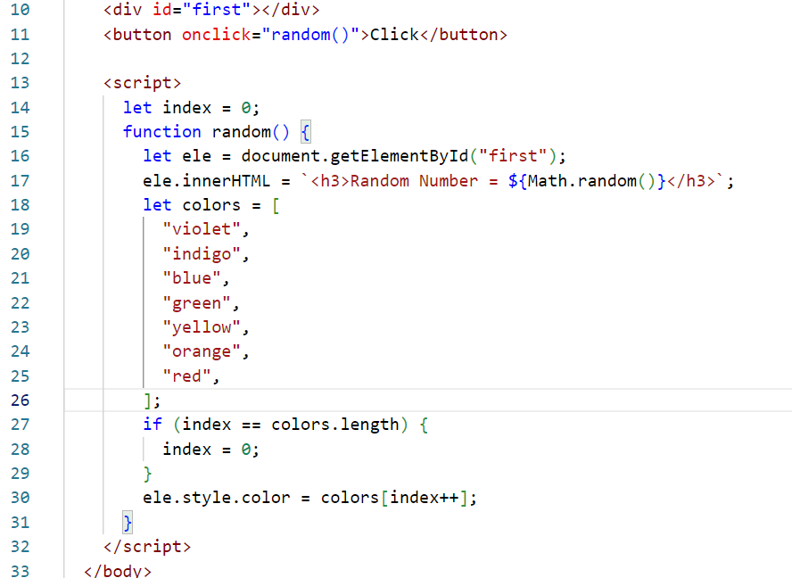
Accessing the HTML element using event object
Every HTML element that generate the event can be identified by using the event.target property
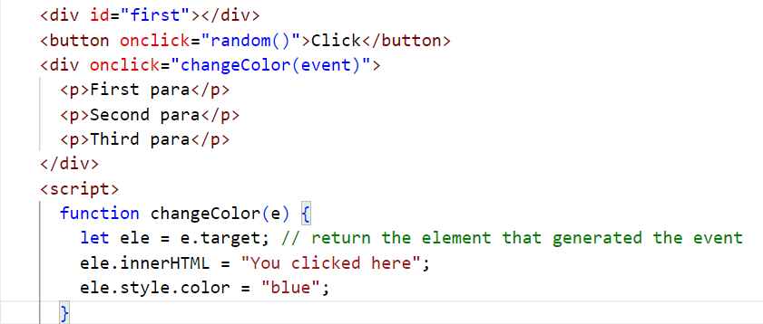
Accessing the attributes using the events
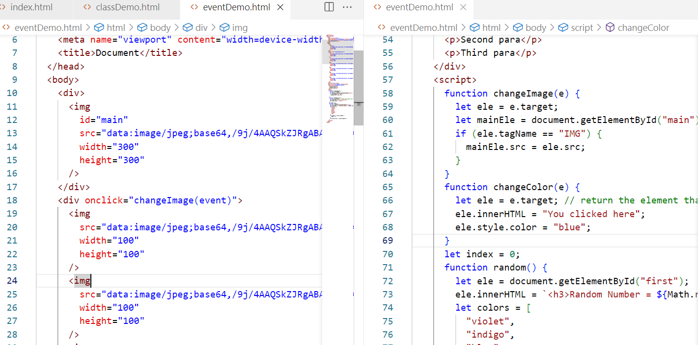
Output:
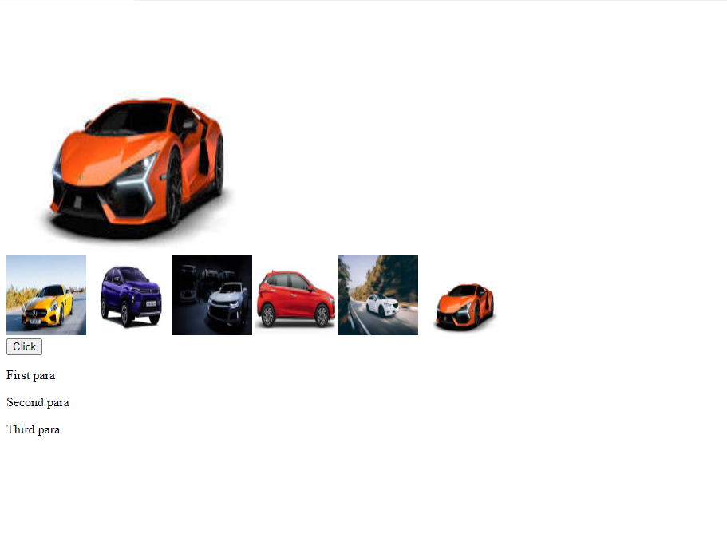
Callback functions: These are the functions that are initiated now but executed later, i.e., when certain event occurs or when a response arrives
Callback functions are generally passed as a parameter to another function
ex: when you iterate an array you can use some inbuilt functions like forEach(), map(), sort() and so on.
let items = [ 20, 30, 10, 50, 40 ];
for(let index = 0; index < items.length; index++) { … } // traditional approach
You can also iterate using forEach function, which is part of an array
items.forEach( callbackFn(value, index){} )
Note: forEach automatically calls the callbackFn by passing the iterated value to the 1st parameter & index to the 2nd parameter
Note: You can give any name to the parameters.
Arrow function:
It is introduced in ES6 to simplify writing callback functions, if the callback is only one line then no need to use { } or return if in case callback returns value, and also no need to use function keyword
Note: { } & return is required only if the callback has more than one line
Callback | Arrow Function
function(v) { one-statment } | (v) => one-statement  [or]  v => one-statement
function(v) { return value; } | v => value;
function(x, y) { return x + y; } | (x, y) => x + y;  [or]  (x, y) => { return x + y; }
function(x, y) { console.log(x+y) } | (x, y) => console.log(x+y);
function(x, y) { 1st line; 2nd line } | (x, y) => {1st line; 2nd line }
function(x, y) { 1st line; 2nd line; return value } | (x, y) => {1st line; 2nd line; return value; }
ex: forEach ( function(v, i) { } ) | ex: forEach( (v, i) => { } )
ex: map(function(v, i) { return v + 2; } | ex: map( (v, i) => v + 2 );
Replacing all the callbacks to arrow function
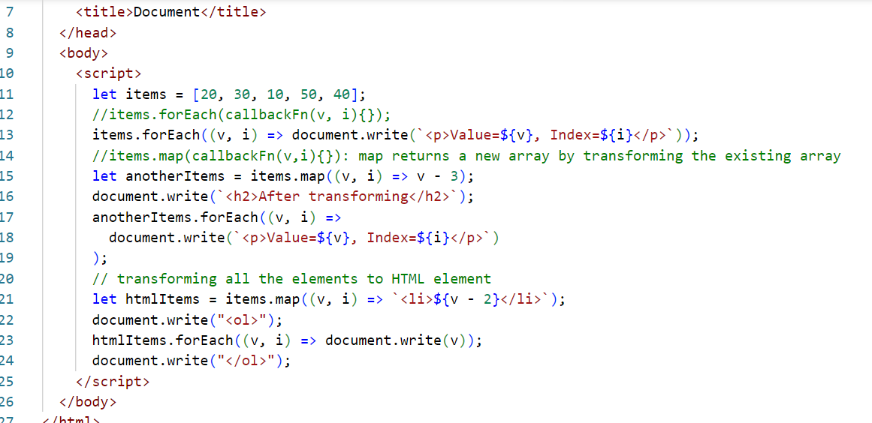

Activity:
Assuming you have an array of objects, print those items in an HTML table, below is the array
Input:
[
{id:1, name:”Vijay”, address : {state:”KA”, city:”BLR”, pin:560001 } },
{id:2, name:”Ajay”, address : {state:”KA”, city:”MYS”, pin:560061 } },
{id:3, name:”Ravi”, address : {state:”MH”, city:”MBI”, pin:760001 } },
{id:4, name:”Siddharth”, address : {state:”TN”, city:”CHN”, pin:660001 } }
]
Output:
Id | Name | State | City | Pin
1 | Vijay | KA | BLR | 560001
2 | Ajay | … | .. | ..
… | .. | … | .. | …
…. | .. | . | .. | .

TypeError: Whenever we try to access the nested properties there could be chance that nested properties may not be present, in that case you get type-error, to avoid this developers used if(value.address != undefined) { then access value.address.state }
Optional Chain(?.): ES8 added new feature called Optional chain that will access the nested property only if the property exists
value.address?.state // if address is not undefined then access state.
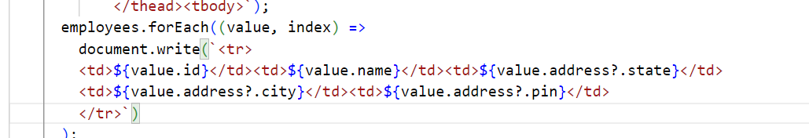

Rest & Spread operators
Rest operator: When a function needs to accept an optional parameter or 0 or more parameters, then you can use rest parameter
Earlier data’s were lost when there are no parameters to accept some values
ex: function test(x, y) { }
now you can call test by passing only 2 parameters, but if you pass more than 2 parameters then all those data will be lost
function test(x, …y) { } // here y can accept 0 or more parameters, y also acts like an array
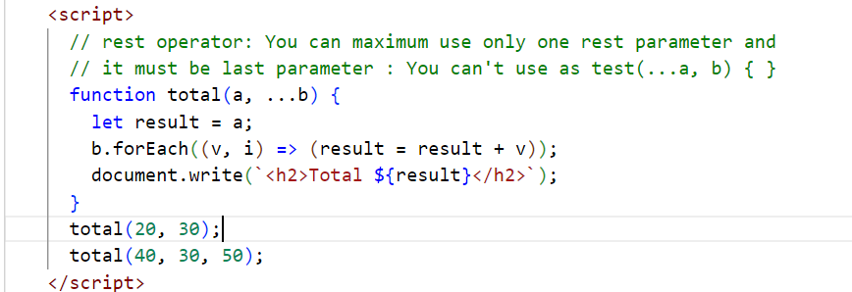

Spread operator: It is similar to rest parameter, however used to distribute the list of values to multiple parameter of a method, used while calling the method
function test(x, y, z) { }
let items = [20, 10, 30];
test(items); // x = [20, 10, 30], y = undefined, z = undefined
// spread operator
test(…items); // x=20, y=10, z=30;
Note: If the number of parameters in the function is less, then the last parameter must be the rest parameter, so that the last parameter accepts rest of the values
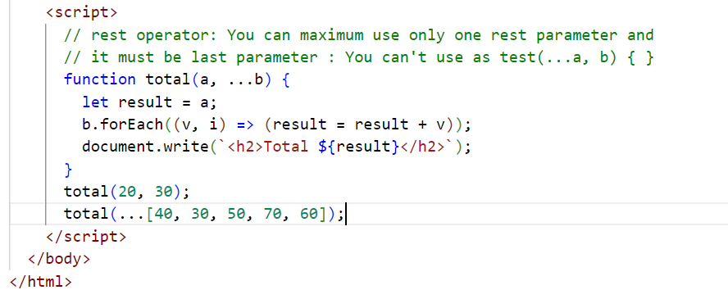

Destructuring: It is used to assign values of the array or an object to a separate variable in a single line.
Earlier:
let items = [20, 10, 30, 50];
If each item needs to be assigned to separate variables
let a = items[0];
let b = items[1];
let c = items[2];
let d = items[3];
let obj = { id : 1, name : “Raj”, salary: 45000 };
let id = obj.id;
let name = obj.name;
let salary = obj.salary;
From ES6 onwards you can use destructuring
Array destructuring
let items = [20, 10, 30, 50];
let [a, b, c, d] = items; // each item is assigned to the variables in the order they appear
Object destructuring
let obj = { id : 1, name : “Raj”, salary: 45000 };
let { id, name, salary } = obj;
function test([a, b, c, d]) // array destructuring
test(items);
function display( {id, name, salary} ) { } // object destructuring
display( obj );

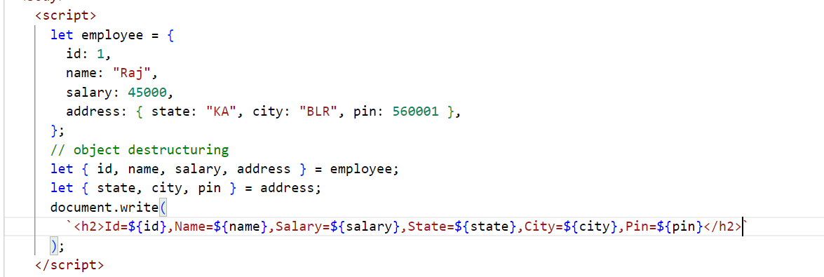

Default values: When a parameter doesn’t get any value this default value will be given
function test(x = 0, y = 0) {
}
test(); // x & y will be 0
test(2); // x = 2, y = 0

How to access backend services from javascript
Whenever front-end sends the request to the backend services it gets the data in the form responses, there are few approaches javascript uses
- Old approach : XMLHttpRequest which is callback based
- New approach: fetch which is Promise based
- Enhancement to the Promise: async/await
XMLHttpRequest: It is an object used earlier to make HTTP calls(HTTP requests) to the backend, it gets the response through some events and invokes the callback based on those events, list of properties & functions in XMLHttpRequest
- readyState: it maintains the value ranging from 1 to 4, if 1 then request is initialized, if 2 then request is sent, if 3 then half of the response is ready, if 4 then full response is ready means request is complete
- responseText: it maintains the response data
- onreadystatechange (everything in lowercase): this generates an event each time the readyState value changes & it invokes the callback attached to this
- open(httpMethod, URL): to initialize the request with HTTP methods & URL
- send(): to send the request
In order to send HTTP request to the json placeholder we must use HTTP GET method & an URL
<input id = “i1” > <button onclick=”getData()”>Get Data</button>
function getData() {
let id = read the #i1.value
let url = “url/”+id;
let http = new XMLHttpRequest();
http.open(“GET”, url);
http.send();
http.onreadystatechange = callbackFn() { …when readState==4 read responseText. }
}
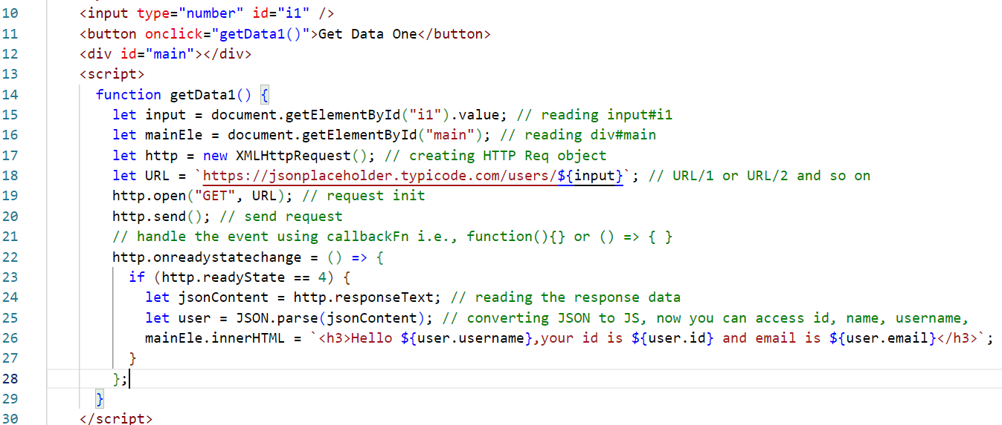
Output:

Promise based:
Promise is an object that will have two status based on the request
- Resolved: If the promise is fulfilled / success then it is treated as resolved
- Rejected: If the promise is rejected/failed then it is treated as rejected
Promise provides two methods to handle success & failure, those are then(callback) and catch(callback)
then(callback): it is invoked when the promise successfully resolved
catch(callback): it is invoked when the promise is failed or when there’s any error
both of them takes callback which is executed based on the promise successful or reject status
fetch(URL): It is an inbuilt method that returns a Promise when the request is made, this can be resolved or rejected
fetch(URL).then( callbackFn ).catch( callbackFn )

getData2() {
let id = read the #i1.value
let url = “url/”+id;
fetch(url).then( (res) => { } ).catch( (err) => { } )
}
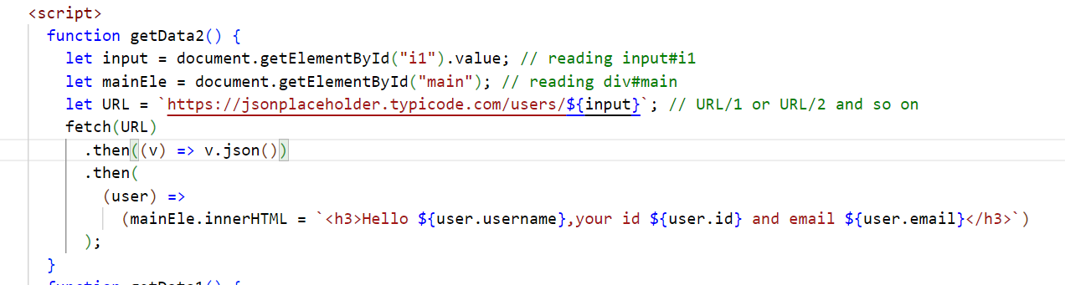
Async/Await: It is used whenever you need to wait for the asynchronous operations to complete and then you want to proceed
async function getData3() {
let res = await fetch(URL) // no need to use .then() or .catch
print res; // executed only if the Promise is either rejected/resolved
}

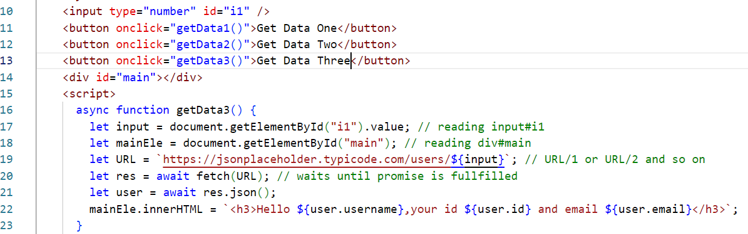

Getters & Setters in Javascript
These are functions that can read and write the data of an object
class Employee {
constructor(id, name, salary) { … }
set empId(id) { … }
get empId() { return this.id }
set empName(name) { … }
get empName() { … return this.name.toUpperCase(); }
set empSalary(salary) { if(salary == this.salary) alert(‘trying to update salary with same value’)
}
let e = new Employee(1234, “Rajesh”, 45000);
e.empId = 2545; // calls empId(2545) >> id = 2545
console.log(e.empId) // returns 2545 & prints in the console

React.js: It is a Javascript library used to develop single page applications (SPA).
SPA: Everything happens in one single page, it updates part of the page without reloading the entire page
Components: These are reusable UI’s which you can develop and use independently wherever is necessary
ex: Profile is a component that will have image & name that is used in comment, like, post, friends list etc in Facebook
React.js uses following languages
- HTML
- JSX - Javascript XML - Extended form of Javascript - It simplifies writing HTML code in Javascript
Note: Browser doesn’t understand JSX, hence React.js uses babel which is a transpiler that converts JSX to Javascript
HTML in Javascript
content = ‘<div><p>Hello ‘+name+’</p></div>’
or
content = `<div><p>${name}</p></div>`
HTML in JSX
content = <div><p>{name}</p></div>
React.js uses 3 libraries to develop the application
- React: It is to create components & other features
- React DOM: It updates the Real DOM i.e., browser DOM
- Babel: It compiles/transpiles JSX to Javascript
React applications can be created either by
- Using Online CDN Link - this is only for learning purpose
- Using React Tool Kit - provided by react community - this is used in real time

Root node: It is an HTML element which loads all the components
Root component: This is the component that is going to nest all other components, and it is loaded into the browser DOM

Adding CDN links
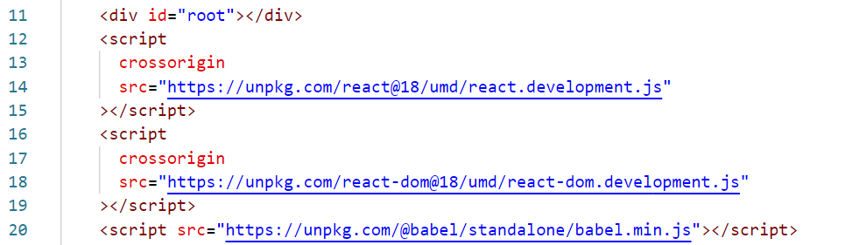
Script with text/babel
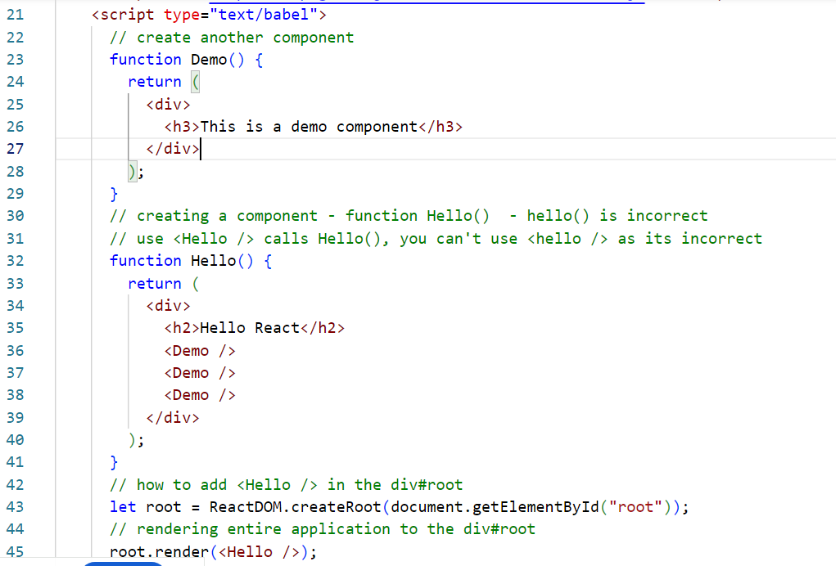
ReactDOM: It is a virtual DOM that updates the original DOM by comparing the original DOM content with virtual DOM content, it only doesn’t update the DOM if the contents are same & does changes only to the content that needs
Javascript doesn’t compare the previous content while updating the DOM
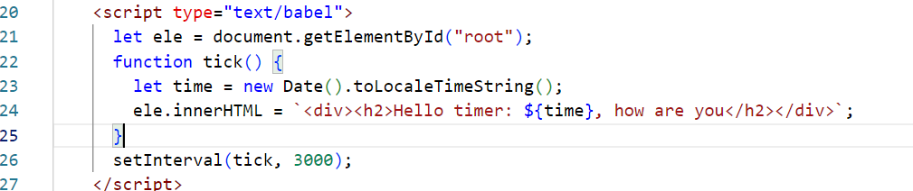
Output
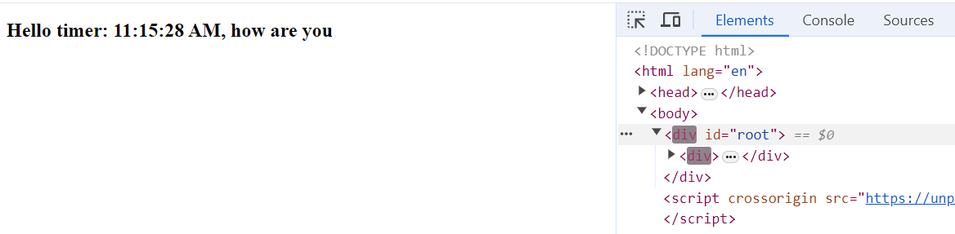
It updates the entire DOM, just to modify the time, however React.js resolves these issues with Virtual DOM
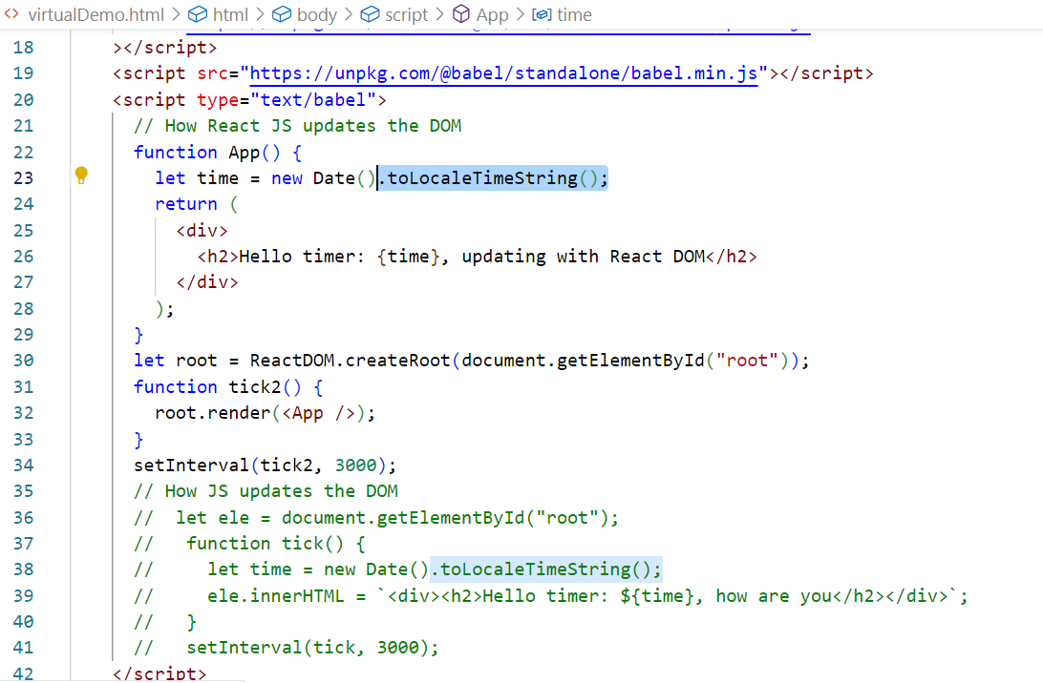
Output:
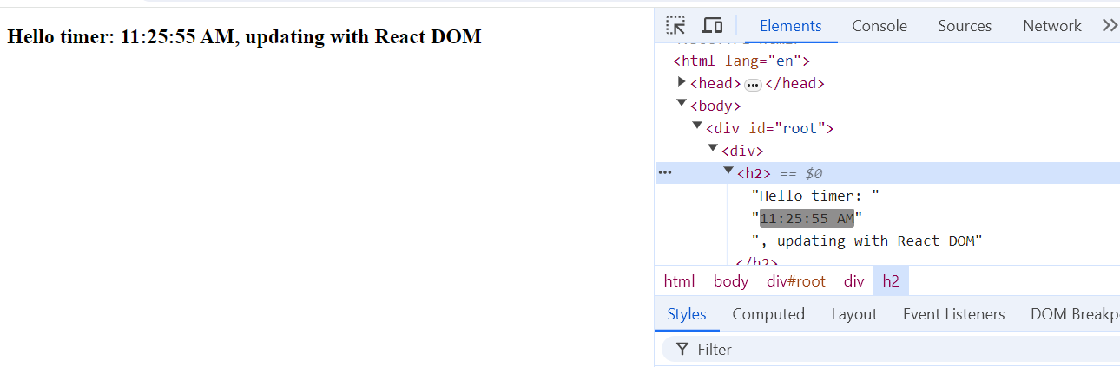
React Tool Kit: It is provided by React community to quickly create a ready to run react application
Benefits
- It organizes all the files and folders in a standard way
ex: Keeps all the JS in src, html in public folder
- It comes with inbuilt liver server
- It automatically compiles the code
- It provides commands to launch, test and build the application

Ways to use react tool kit
There are 2 ways
- Installing & creating the project: npm install -g create-react-app, then download the project using create-react-app app-name
- Directly downloading the project without installation: npx create-react-app app-name

Props: These are components data that can be supplied from one component to another component
<Welcome username=”Kishor” emailId=”kishor@gmail.com”/>
<Welcome username=”Ajay” emailId=”ajay@gmail.com” />
function Welcome(props) {
let username = props.username;
let email = props.emailId;
return Welcome {username}, your email is {email};
}
Hello.js
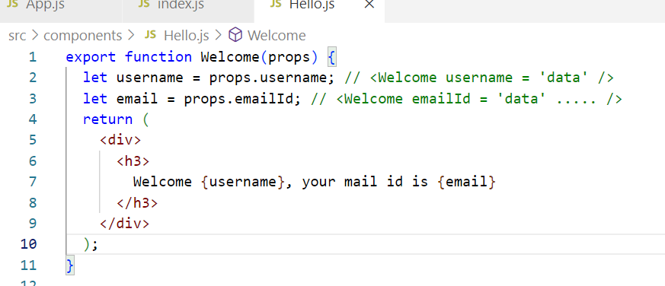
App.js
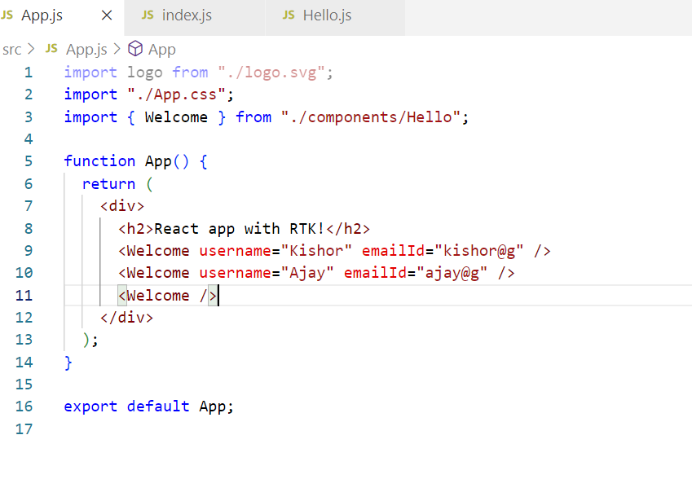
Conditional rendering
Based on the conditions you can render the content
if(username==undefined) { return <div>Welcome Guest </div>}
else { <div>return {username} your id {email} </div> }
OR: You can use ternary operator( ?: )
return (username == undefined)
? <div>Welcome Guest</div>
:
<div>Welcome { username } </div>

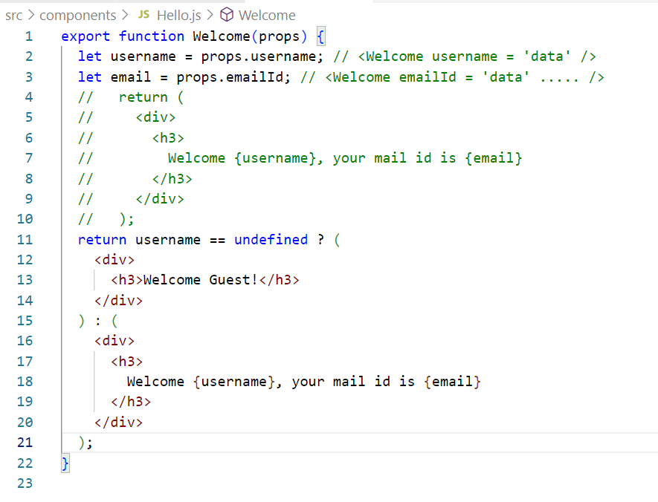

Activity:
Create a component Avatar that displays the image, reuse this component inside Comment component
Create a component Comment that reuses Avatar component by passing image url and width & height 100 * 100 to the Avatar component, comment component must display Avatar & below that username, comment text and date.
App component passes comment to the Comment component as below
<Comment comment = { username: “Raj”, imageUrl : “googleImageURL” , text: “some text” date = “2024-06-14”} />
Output:
Image
Username: “Raj”
Your comment : Some text
Date : 2024-06-14
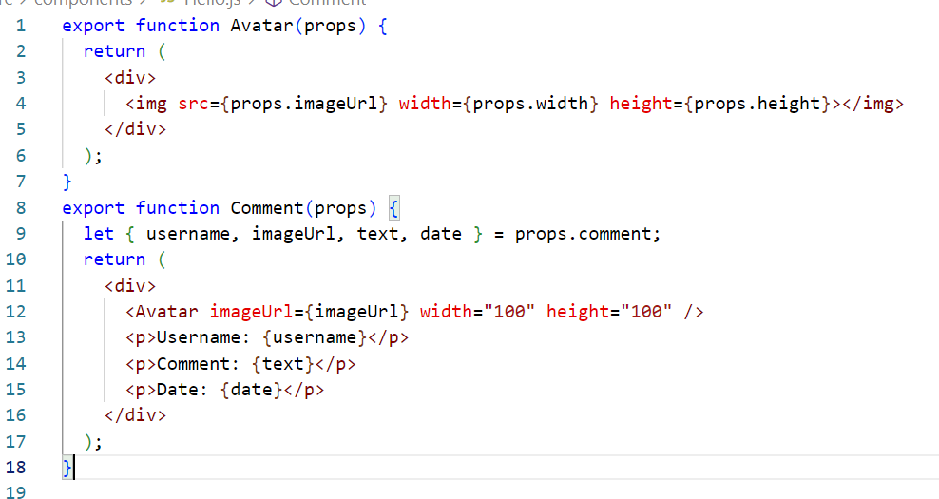
App.js
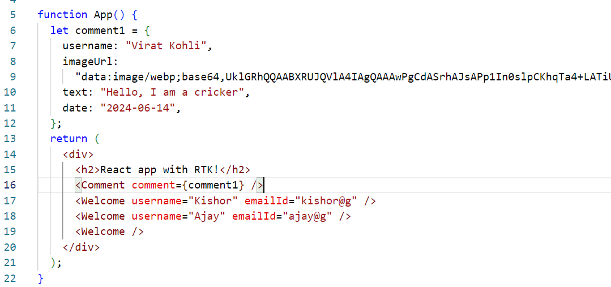
Output:
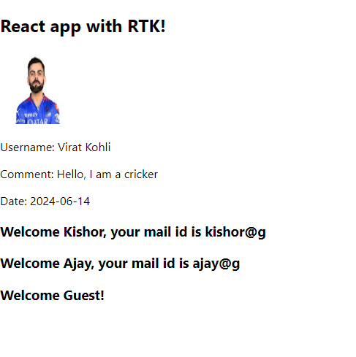
How to apply CSS in React
- You can write classes in .css files & use their names
- You can download third party css and use their classes
App.css
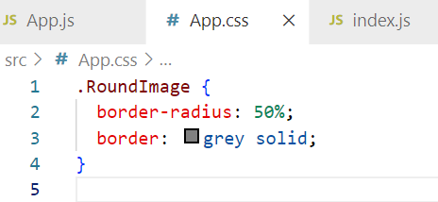
Hello.js
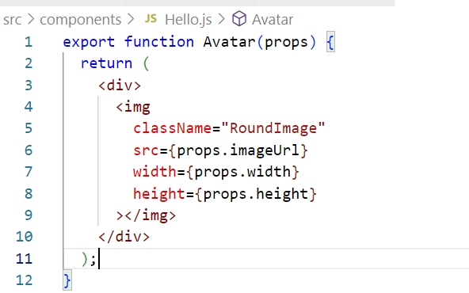
Output:
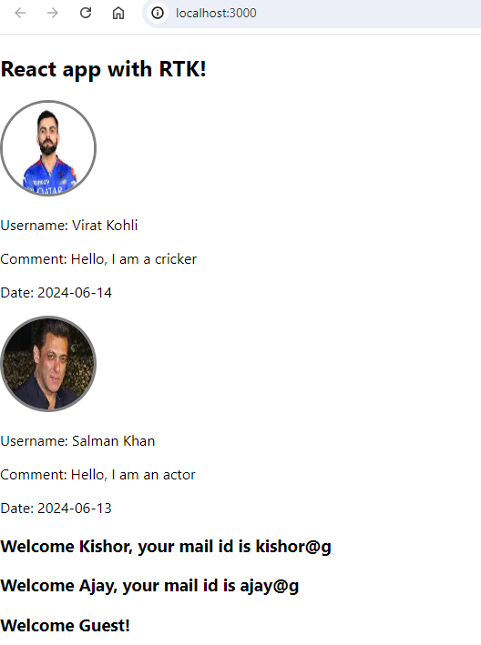
Adding 3rd party CSS
You must download the css in your project, so that it will be part of the build also, you must import either in index.css or index.js
npm install bootstrap or npm i bootstrap
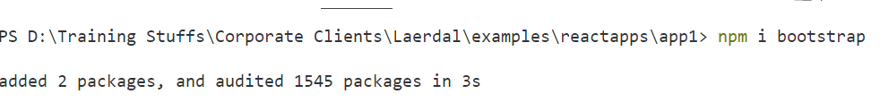
Note: You can observe the bootstrap folder inside node_modules
index.css
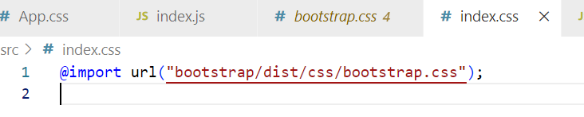

How npm start works
npm start >> package.json >> runs scripts present in node_modules >> they launch index.js & index.html
How to change port number
React.js internally uses .env file that has server configurations, you can create .env file inside the project & mention the port
Types of components
- Function based component - components which you create from functions
- Class based component - components which you create from classes
Difference between class based components & function based component
 | Function | Class
Usage | function App() { return content } | class App extends React.Component {  render() { return content }  }
Features before 16 | Components are read-only, supports only props, but no states | Components are read and write both, supports props(read-only) and states(read & write)
Feature before 16 | No life cycle methods | Has life cycle methods
Features above 16 | Function supports all the features class supports because of react hook functions

How to create components using classes
class Demo extends React.Component {
render() {
// automatically called to render the content
}
componentDidMount() { } // life cycle method called when component is added to the DOM
componentWillUnmount() { } // life cycle method called before component is removed from the DOM
}
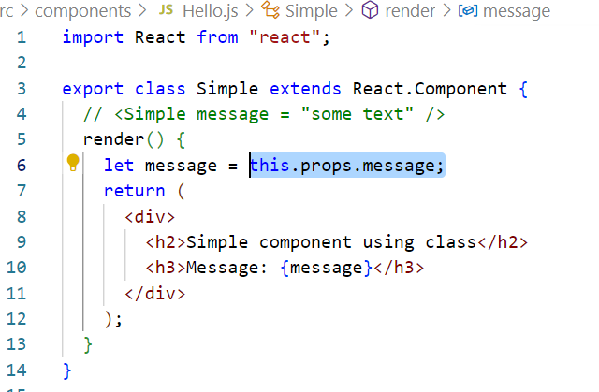
Render the component in the App component
<Simple message = “some text message” />
src/App.js
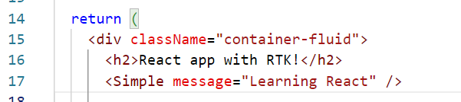
Stateful components
Components that can have states which are modifiable, earlier functions were not supporting the states only classes were supporting the states, but from react v16 onwards functions also support the states.
How to create states in functions
React has provided an inbuilt hook function to support states in the function based components, this hook function is available from react v16 onwards.
Note: hooks can be used only in function based components, it can’t be used in classes
useState(initValue): It is a hook function, that provides a variable & a function to modify the variable value
let [username, setUsername] = useState(“Guest”)
let [email, setEmail] = useState(“Not Provided”);
To modify you must use the 2nd property of the useState i.e., setUsername & setEmail
How to modify the state
- You must handle an event & modify the state
- You must get the data from the backend & modify the state
How to handle the event & modify the state
React handles the events using the event names which is similar to Javascript events, but it uses camel-case
onclick = onClick
onsubmit = onSubmit
onchange = onChange
onblur = onBlur
We must attach an event handler to these events, which are executed when the event occurs
<button onClick = { ()=> { statements } >MyButton</button>
[or]
let handleClick = () => { …. }
<button onClick = { handleClick } >MyButton</button>

Summary
- SPA
- React.js libraries
- Components
- Props
- Conditional rendering
- Virtual DOM
- States
- CDN link & RTK

Vite: It is a tool provided by react community to quickly develop react application, you can use this as an alternative to RTK
npm create vite@latest myapp2
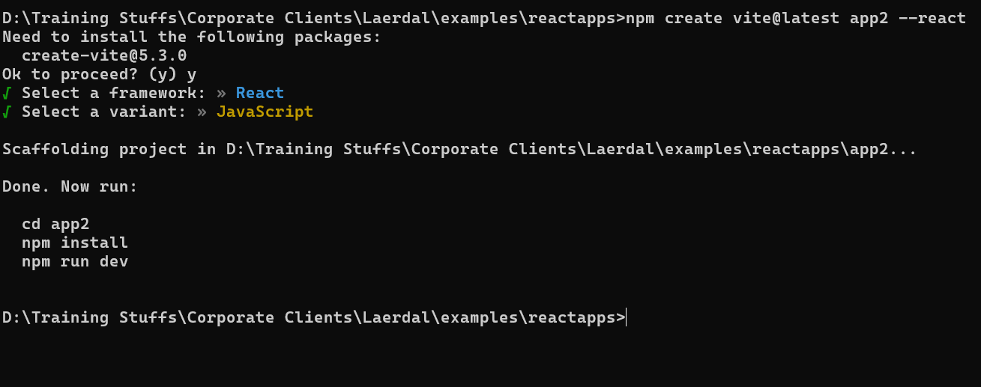
npm run dev is used to launch the app
Contact Management System
This system must allow user to maintain the contacts of their families & friends
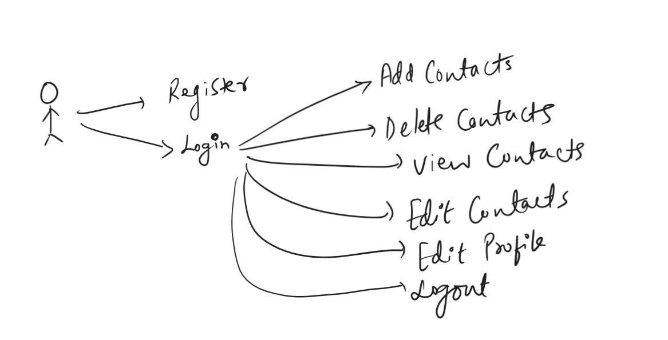
UI
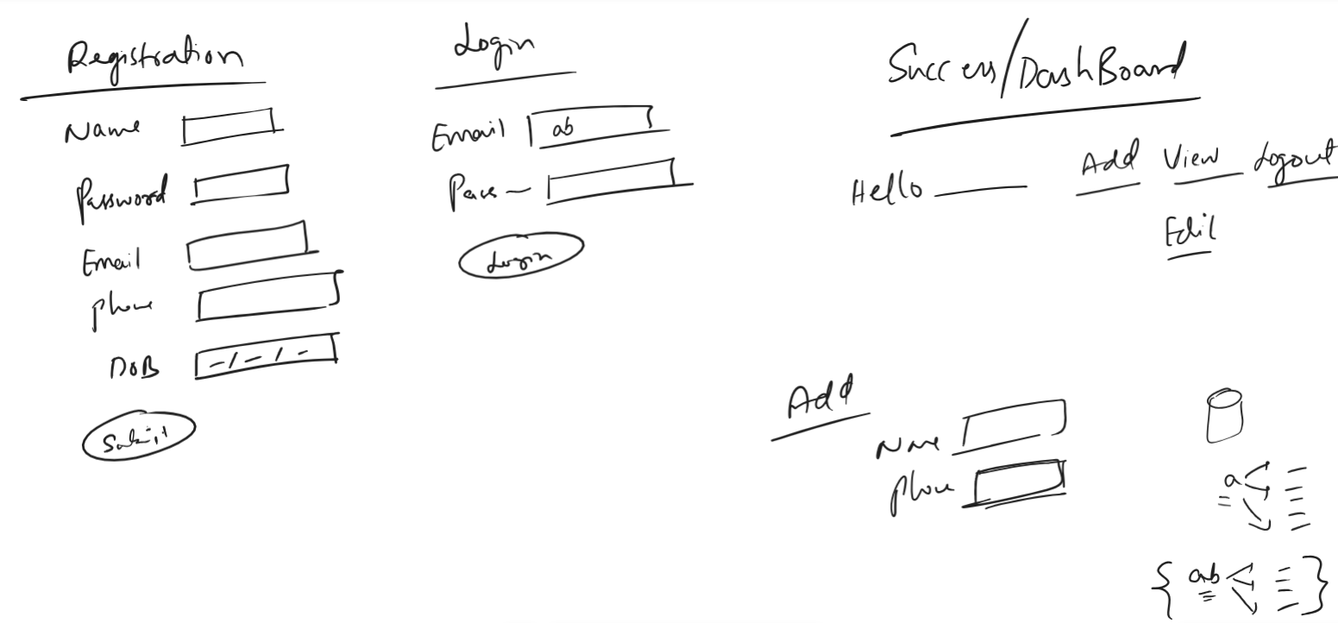

Profile.jsx
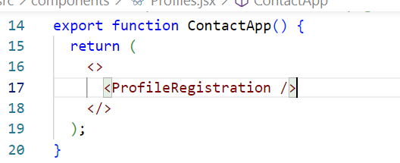
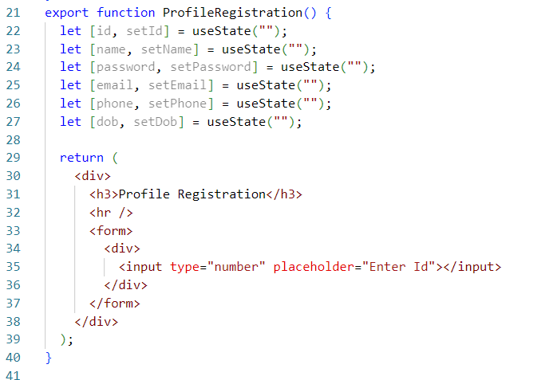
App.jsx
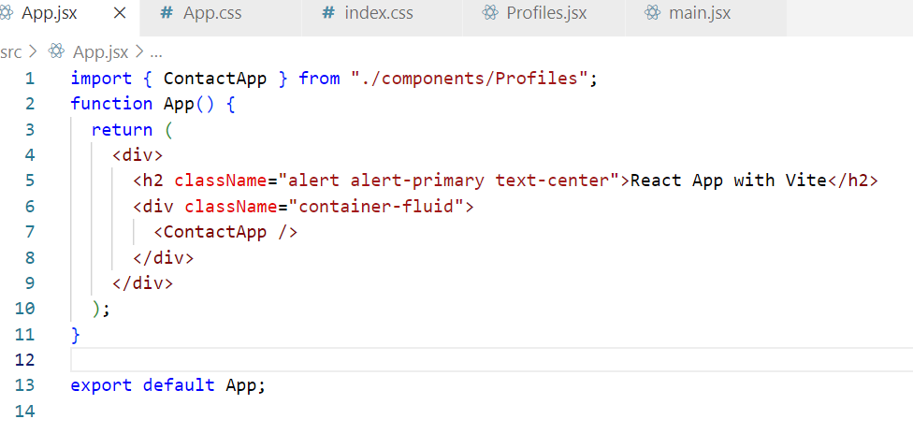
How to handle the input values of the form
<input onChange = { (e)=>setName(e.target.value) } /> setName
<input onChange = { (e)=>setEmail(e.target.value) } /> setEmail

How to prevent the page reload on form submission
We must handle the submit event and call the preventDefault() function
let handleSubmit = (e) => {
e.preventDefault();
//submit the data to the server
}
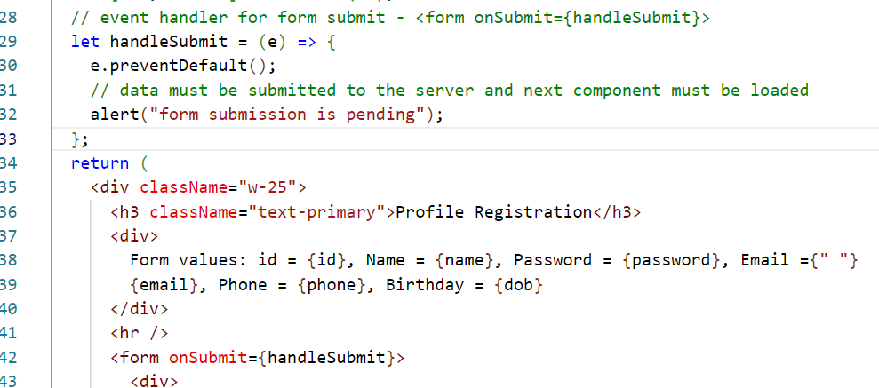
List & Keys in React
List is an array of elements, you must iterate the List using map() function
let items = [‘twitter’, ‘facebook’, ‘instagram’];
items.map( (value, index) => <p key={index}> { value }</p> );
Complex objects can also be iterated
let users = [ {name:”A”, age:25}, {name:”B”, age:26} ] ;
users.map( (value, index) => <tr><td>{value.name}</td><td>{value.age}</td></tr> )

Profiles.jsx
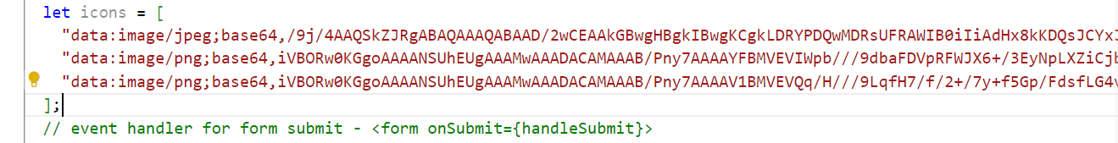
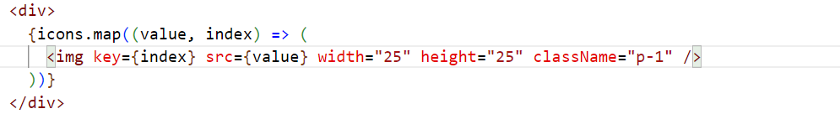
Creating View Contacts to display name, phone
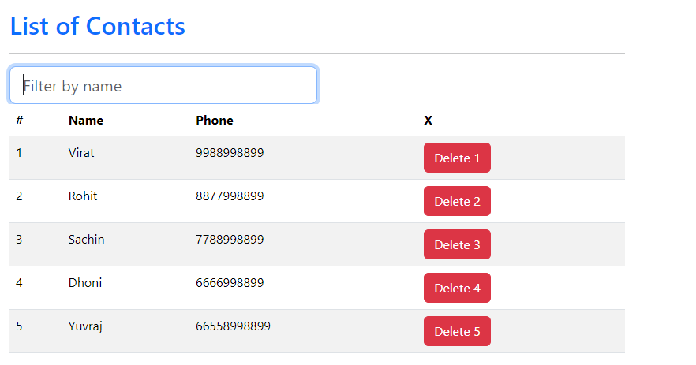
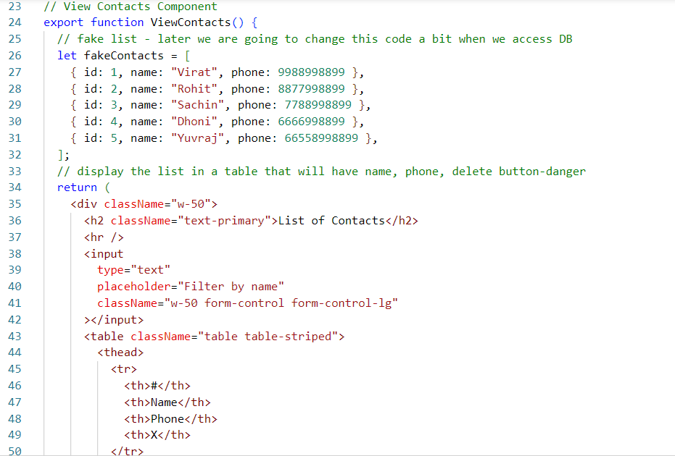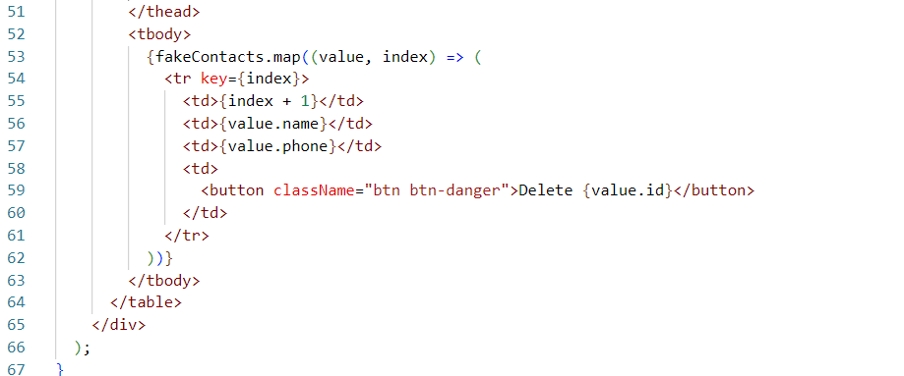

React Router DOM
It is used to navigate from one component to another component, it is a 3rd party library which we must download using npm install react-router-dom
This library gives us some components & hooks that helps you to navigate and also extract the data while navigating, which are
- <BrowserRouter>
- <Link>
- <Routes>
- <Route>
- useNavigate()
- useParams()
<BrowserRouter>: This is a component that helps to load the component without loading the entire page, we must keep all the components inside this.
i.e., <BrowserRouter>
<App />
</BrowserRouter>
<Link>: This is used to create hyper links just like <a> , <Link> passes the url to the BrowserRouter so that it can map the component based on the url
i.e., <Link to = “/url”>LinkName</Link>
Routes & Route: These are used together, Routes keeps multiple Route, it loads any one Route based on the url, Route will have the configuration of url mapped to the component
<Routes>
<Route path = “/a” element = { <ComponentA /> } />
<Route path = “/b” element = { <ComponentB /> } />
<Route path = “/c” element = { <ComponentC /> } />
</Routes>
useNavigate(): This is used to programmatically navigate, it is a hook function that is used like this
let nav = useNavigate();
if(…) { nav(“/url”) }
else { nav(“/url”) }

Import all the functionalities
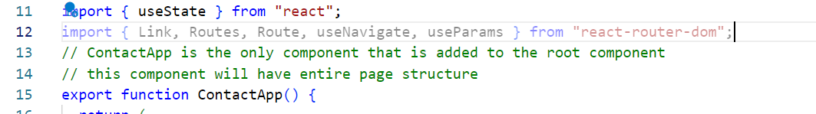
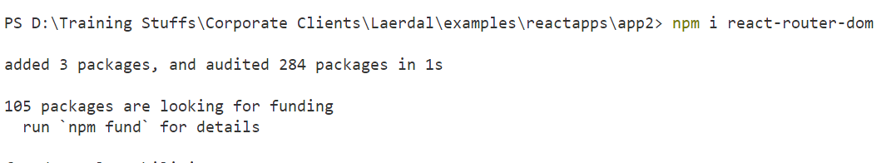
main.jsx/index.js
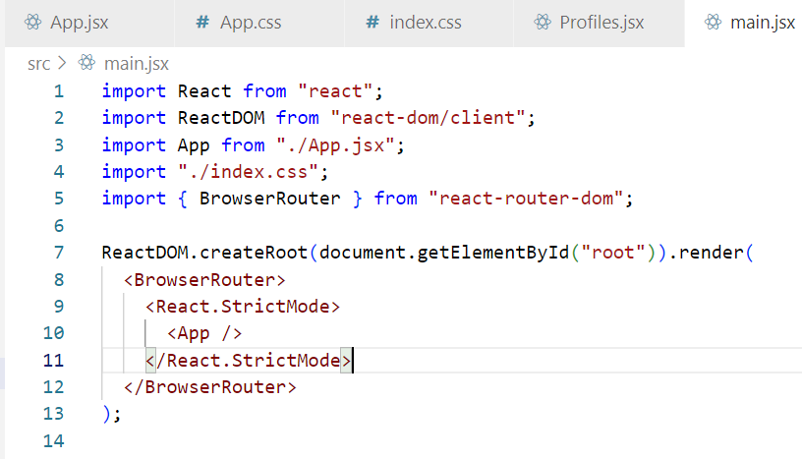

Using <Link>, <Routes> & <Route>
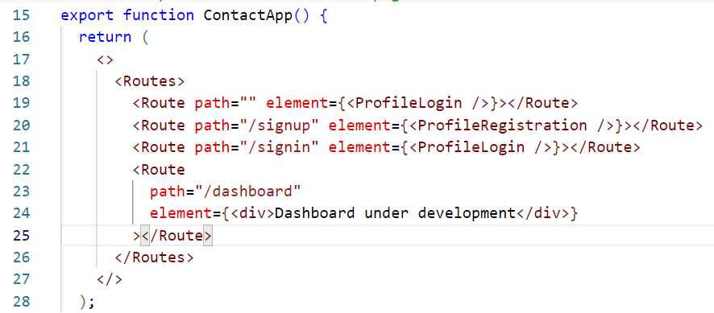
Adding <Link> to ProfileRegistration in the Login Component
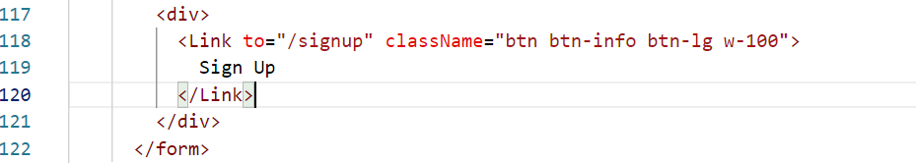
Add <Link> to ProfileLogin in the ProfileRegistration
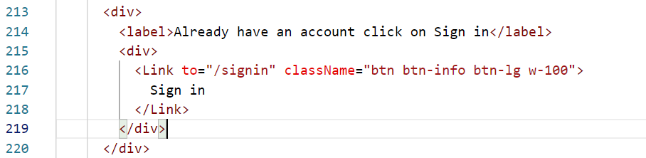
Output:
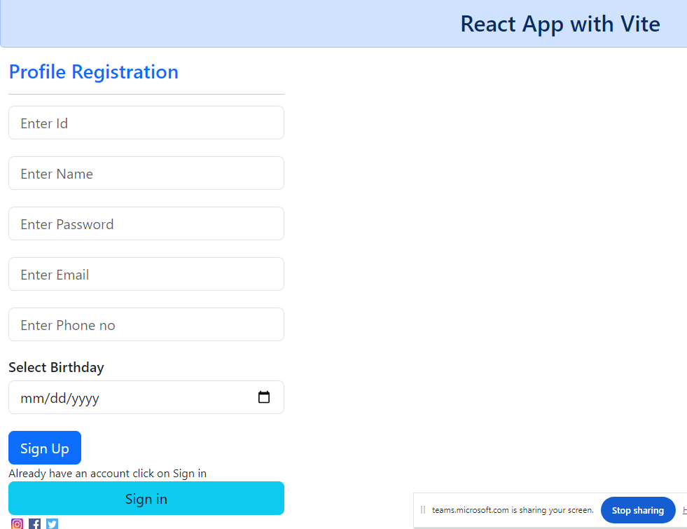

Programmatic navigation
let nav = useNavigate();
nav(“/dashboard/”+id)
Here id can be any value, like 1, 2, 3, and so on, hence we must have a Route to take any value in the path
<Route path = “/dashboard/:id/*” element = { <ProfileDashboard /> } />
ProfileDashboard loads on following path
dashboard/1/addContacts
dashboard/2/addContacts
dashboard/3/viewContacts
dashboard/4/viewContacts
:id is a path parameter that can store any value, so that in the code you can read the value
i.e.,
dashboard/1/addContacts stores 1 in id
dashboard/2/addContacts stores 2 in id
Since id is used in <Route path = “/dashboard/:id/*” … /> you can read the :id using hook called useParams()
let { id } = useParams(); id = 1, id = 2, id = 3 so on based on dashboard/1, dashboard/2 and so on

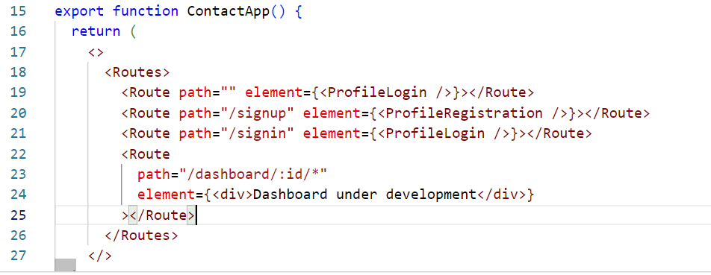
ProfileLogin component
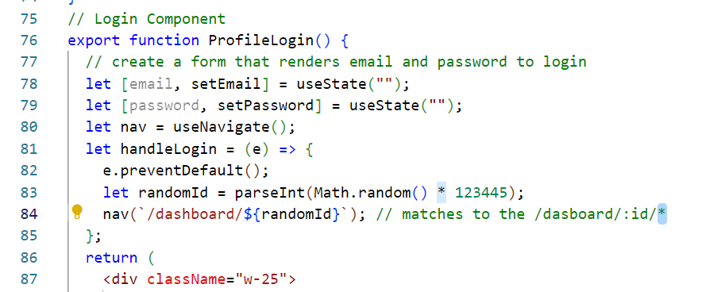

Implementing the Dashboard and Reading the path parameters
useParams() must be used to read the path parameters
let { id } = useParams(); reads /:id
let { id, email } = useParams(); reads /:id/:email
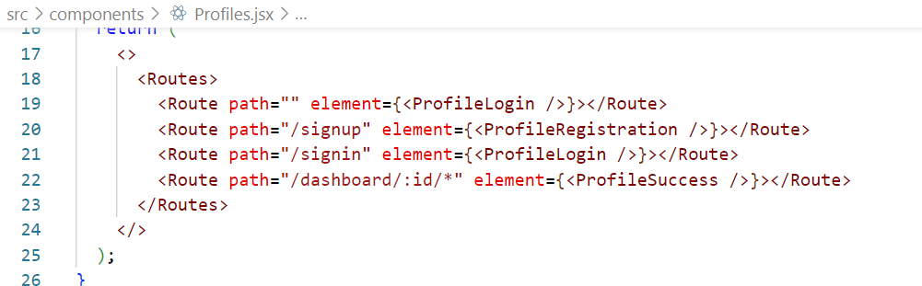

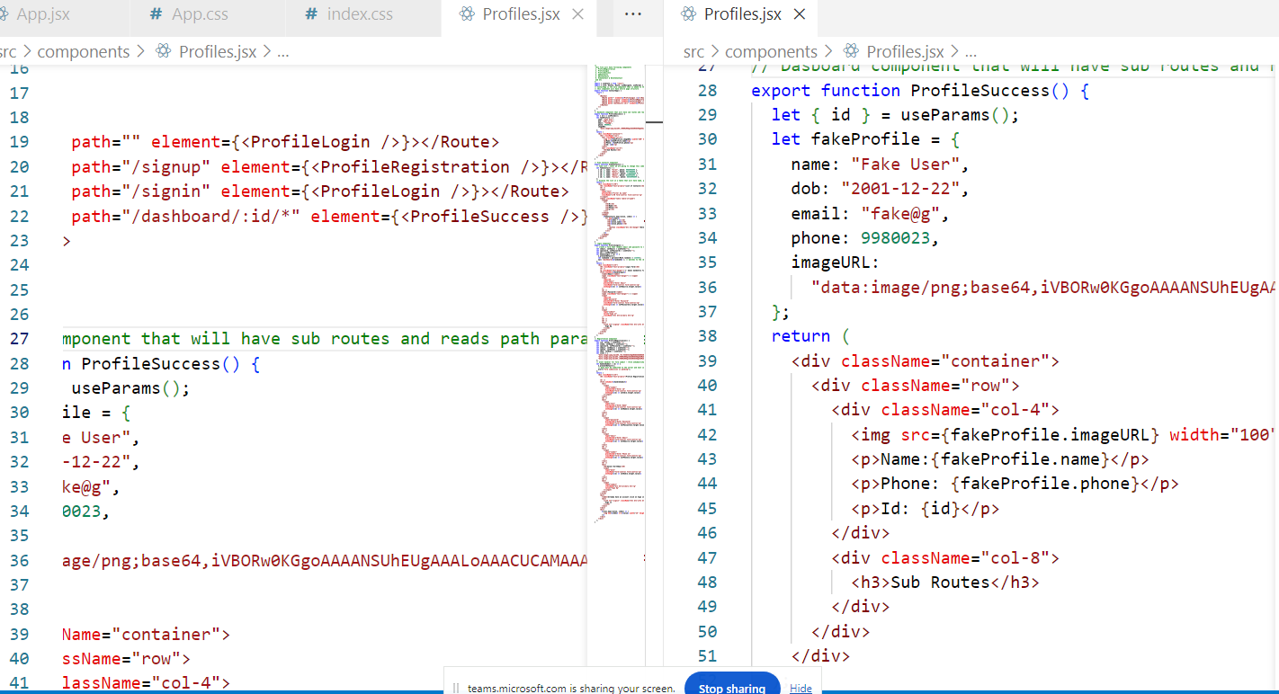
Output:
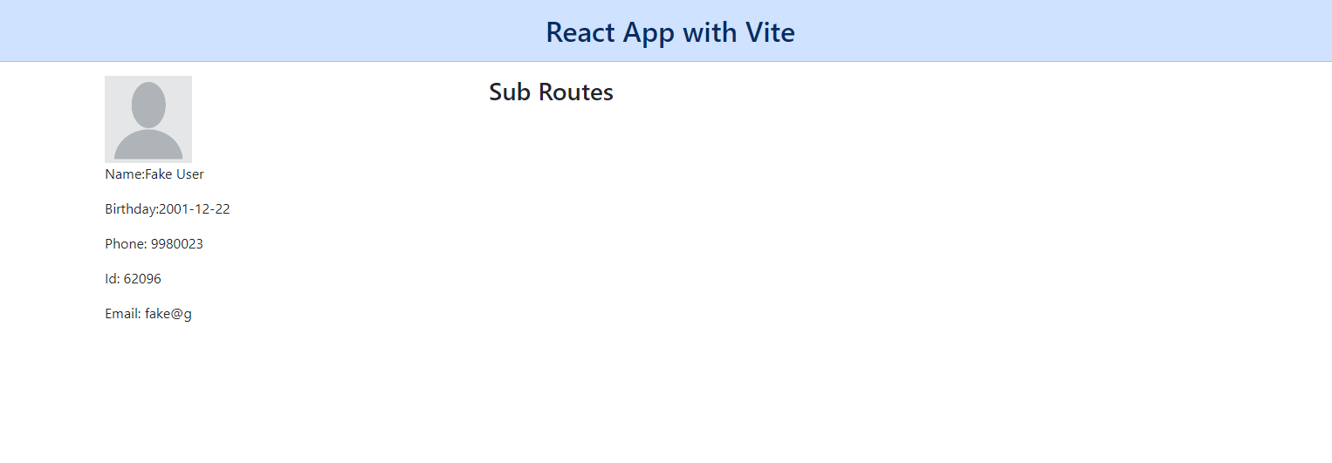
Activity:
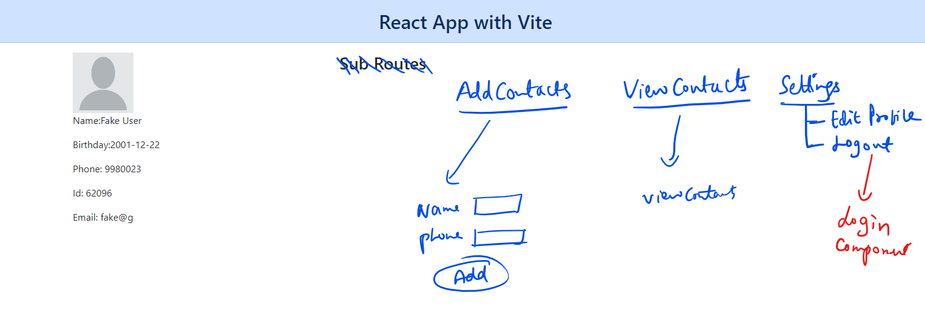

Note: Only at the Right Hand Side the contents will change when you click on the links, the Left Hand Side will not change when you click on any of the links at the right
Note: Create <Routes> & <Route> inside the ProfileSuccess

Summary:
- React with Vite
- React Router
- Child Routes
- List & Keys
- Event Handling
- States

Todays agenda
- Using React how to access backend end API’s
- Developing backend end API’s using Node.js & DB (SQL or NoSQL)

NoSQL: It stores the data in a JSON format, it doesn’t apply rules on the datastructure of the document, i.e., in SQL records must have structure like employee table must have defined columns, accounts table must have defined columns, however in NoSQL records doesn’t follow the structure of other records
MongoDB: It is a NoSQL database, it must be uses 2 commands
- mongod: this is used to start the database, it stores the data in /data/db folder of your root drive/directory
- mongosh: this is used to connect to the database using the terminal

Mongodb shell supports Javascript, you can use all the javascript functions in the shell, Mongodb stores the data in JSON format which is called as document, each document will have an unique id called _id
List of mongodb objects
- Collections: These are like tables that stores the documents
- Documents: These are the records which are stored in the collections
Note: Mongodb is case sensitive
How to store the document in the mongodb
db.collection-name.insertOne( { json data } )
db.collection-name.insertMany( [ { … } , { …. }, { … } ] )
How to read the documents from the mongodb
db.collection-name.find( < filter > );

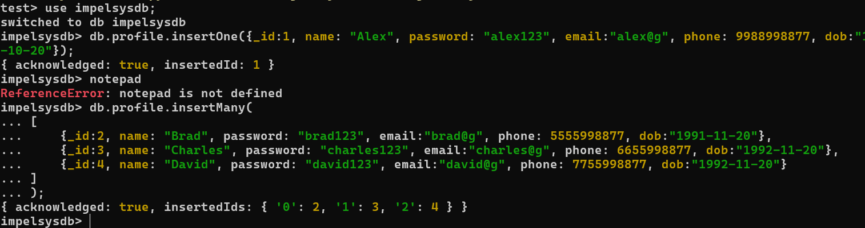
How to interact with the mongodb through different programming languages
Every language gives us libraries example in nodejs we have
mongodb to interact with mongodb
mysql2 to interact with mysql
oracledb to interact with oracle
We need to install these libraries in the project
ex: npm install mongodb
Note: Since React or any UI needs to access these backend programs we need following libraries to be installed in the project like
- express: This is used to create APIs (webservices)
- cors: This is to enable cross origin resource sharing
- mongodb: This is to interact with the mongodb
- mysql2: This is to interact with the mysql

Install all these libraries in the backend project: npm install express cors mongodb mysql2
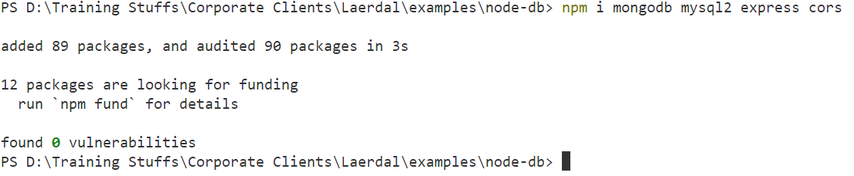

Storing the document
import { MongoClient } from "mongodb";

let DB_URL = "mongodb://127.0.0.1:27017";

// code to connect MongoClient.connect(URL).then().catch()
// code to store db.collection("collection-name").insertOne({})

MongoClient.connect(DB_URL)
.then((client) => {
// access the database-name
let db = client.db("impelsysdb");
// access the collection and store - db.collection("profile").insertOne(doc).then().catch()
db.collection("profile")
.insertOne({
_id: 5,
name: "Edward",
password: "edward123",
email: "edward@g",
phone: 8877555533,
dob: new Date(2000, 15, 20),
})
.then((result) => console.log(result))
.catch((error) => console.log(error))
.finally(() => client.close());
})
.catch((err) => console.log(err));

List of mongodb commands to perform CRUD operations
- insertOne(document)
- find(filter): filter( { _id:2 } ), filter({ name:”Raj” })
- updateOne(filter, document), updateMany(filter, document)
- updateOne({_id:2}, {$set: {phone:883993939}});
- deleteOne(filter), deleteMany(filter)

find & findOne: find returns an array whereas findOne returns single data

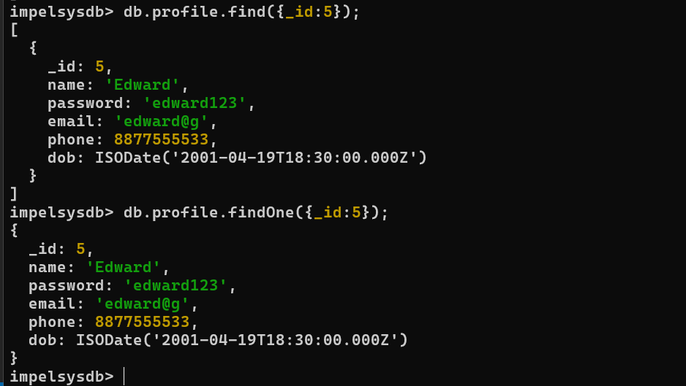
updateOne & updateMany:
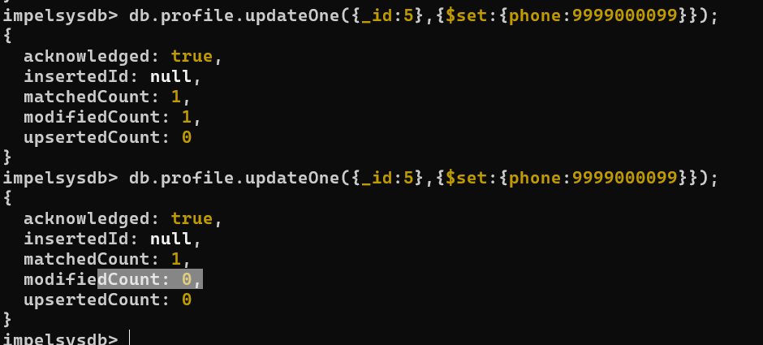
Delete
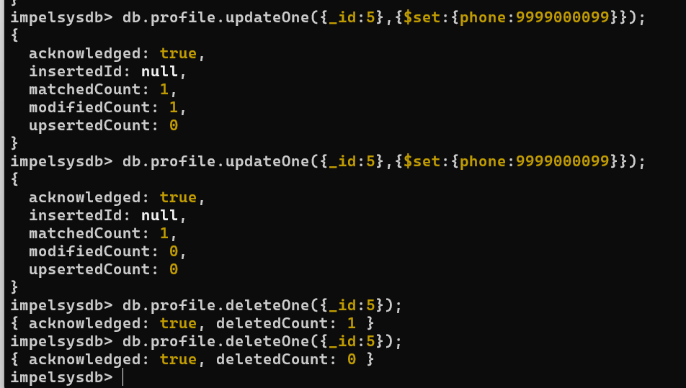

nosql-db-util.js
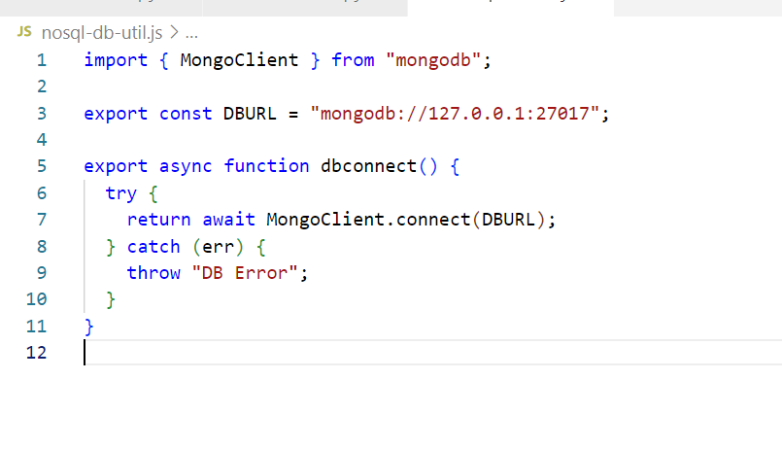
find-in-nosql.js

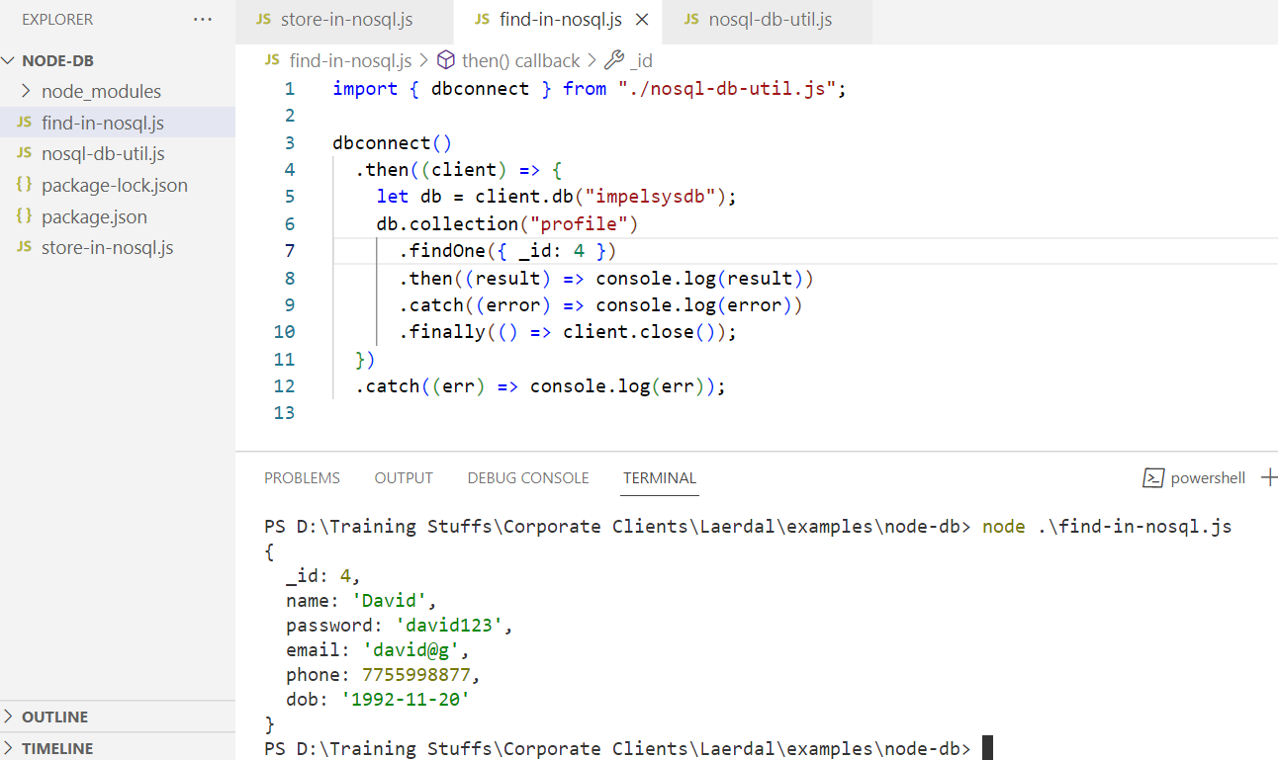
nosql-crud.js
/*
create reusable functions to perform following tasks
1. findAll(): returns a promise that can find all the documents
2. authenticate(email, password): returns a promise that can find the documents using
email & password

3. Test each function in a separate js file
*/

import { dbconnect } from "./nosql-db-util.js";
// storing the document
export async function store(document) {
let client = undefined;
try {
client = await dbconnect();
let db = client.db("impelsysdb");
return await db.collection("profile").insertOne(document);
} catch (err) {
throw err;
} finally {
if (client != undefined) {
client.close();
}
}
}
export async function authenticate(mail, pwd) {
let client = undefined;
try {
client = await dbconnect();
let db = client.db("impelsysdb");
return await db
.collection("profile")
.findOne({ email: mail, password: pwd });
} catch (err) {
throw err;
} finally {
if (client != undefined) {
client.close();
}
}
}
export async function findAll() {
let client = undefined;
try {
client = await dbconnect();
let db = client.db("impelsysdb");
return await db.collection("profile").find().toArray();
} catch (err) {
throw err;
} finally {
if (client != undefined) {
client.close();
}
}
}

Testing
import { findAll, authenticate, store } from "./nosql-crud-util.js";

// store({
// _id: 5,
// name: "Frank",
// phone: 9393939393,
// email: "frank@g",
// password: "frank123",
// dob: new Date(1999, 10, 22),
// })
// .then((result) => console.log(result))
// .catch((err) => console.log(err));
//findAll().then((result) => console.log(result));
//authenticate("alex@g", "alex1223").then((result) => console.log(result));

Express.js
It is used to create webservices. It provides functionalities to create webservices using various HTTP methods
How to import & create our first webservice
import express from ‘express’;
import cors from ‘cors’;
let app = express();
app.use(cors()); // to accept the request from different origin
app.use(express.json()); // to read the JSON data from the request body
app.get(url, callback): callback is invoked when the HTTP GET request comes to the URL
app.post(url, callback): for HTTP POST
app.put(url, callback): for HTTP PUT
app.delete(url, callaback): for HTTP DELETE
app.listen(port_number, callback): callback is invoked when the server starts

profile-api.js
import express from "express";
import cors from "cors";
import { store } from "./nosql-crud-util.js";
// other imports like store(), findAll(), findById(), authenticate() comes here

// express object to call http methods like get, post, put, delete
let app = express();
// adding cors to the express & also parser for json
app.use(cors());
app.use(express.json()); // parser for json to convert to js when request body carries json

// storing the document - import store from 'nosql-crud-util.js'
app.post("/profile", async (req, res) => {
// reading the request body
let doc = req.body;
try {
let result = await store(doc);
res.status(201).json(result);
} catch (err) {
res.status(409).json(err);
}
});

app.get("/greet/:user", (req, res) => {
let username = req.params.user; // reads path parameter :user
// res.json() is used to send the json as the response
res.status(200).json({ message: `Hi ${username}` });
});
// start the server using app.listen(port, callback)
app.listen(8080, () => console.log("Server running in 8080"));

Output:
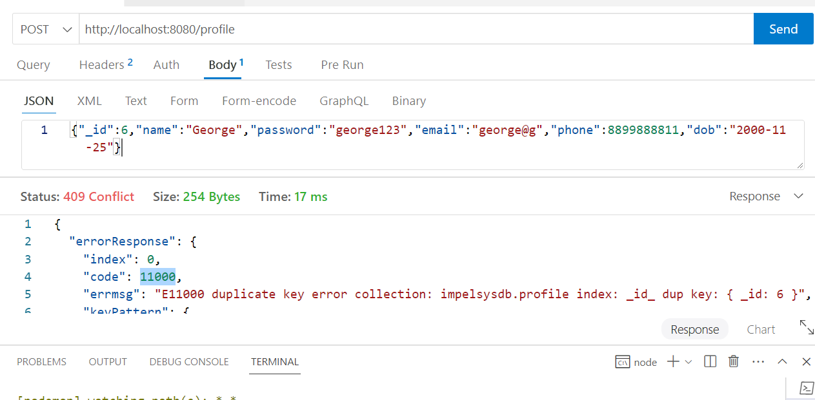

Accessing APIs from react
We need to use axios library, it provides http methods with URL & data
Note: HTTP GET doesn’t support data through request body, however you can send via headers or URL
npm install axios

How to navigate programmatically
let nav = useNavigate(); // from react-router-dom library
nav(‘/signin’);
or
nav(‘/signup’);
Output:
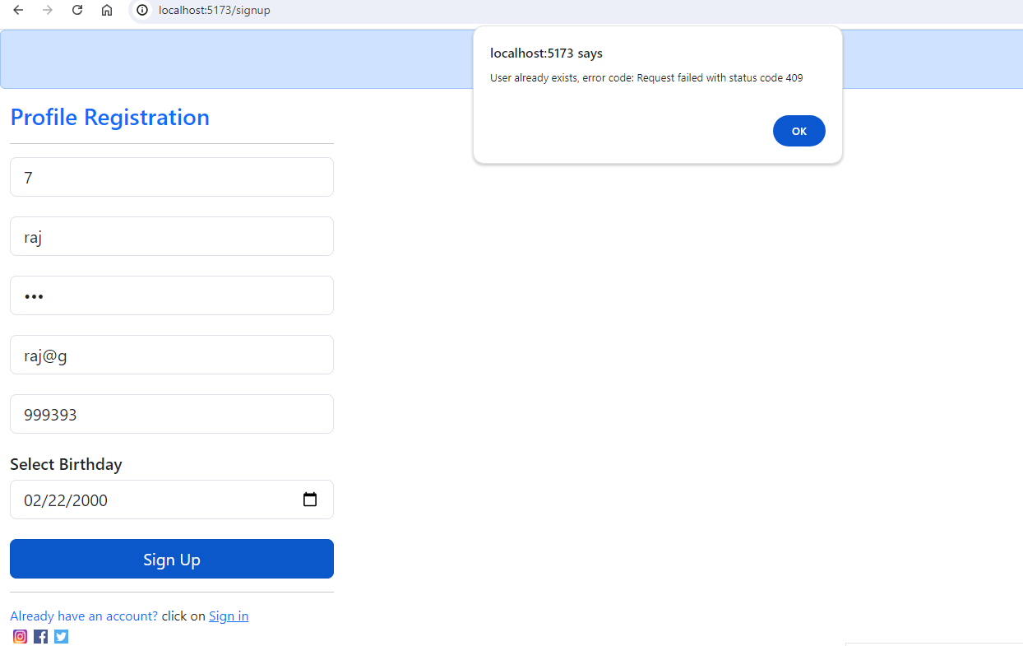
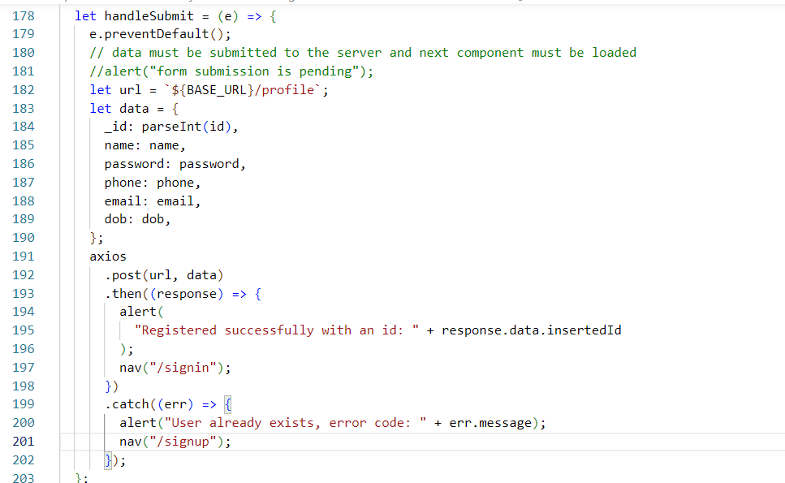

Authentication:
Since password is a sensitive information, we must send in the base64 encoded format, and also GET doesn’t support body, hence we must send the sensitive data via authorization header, backend must read this header.
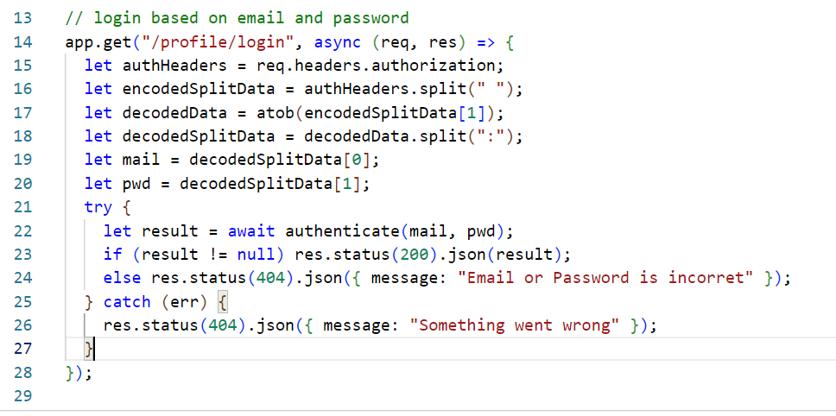

Activity:
- From react, use the login component and send the email & password through the Authentication headers
- Once login is successful show the profile information in the dashboard instead of showing the fake user
- Implement add contacts both at the front-end & back-end, where contact-name & contact-number will be stored as a nested property in the same collection profile
ex: { _id:1, name:”Alex”, …, contacts : [ {contactId: 22, name:”A”, phone:99393], {contactId:33, name:”B”, phone:444] }

Implementing the Authentication from the react side
We must send the credentials data separated by colon & encode it using base64 and add the encoded data in the request header
To encode use the following syntax
let email = “a@g”;
let pwd = “1234”;
let encodedData = Buffer.from(email+”:”+password).toString(“base64”);
Note: Buffer is the library available in npm, which we must install
We can also use btoa() function, like btoa(email+”:”+password)
Sending the authorization to the backend in ProfileLogin
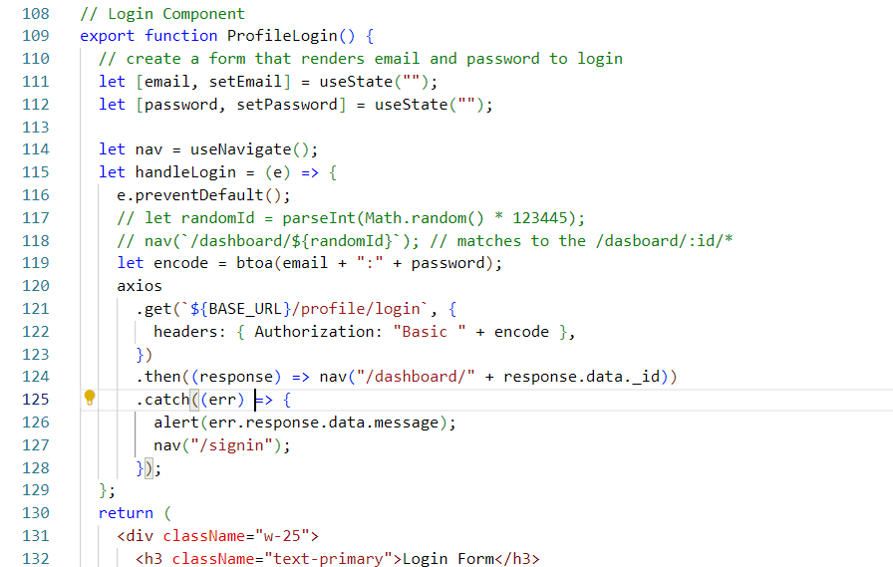

Since the dashboard is showing the fake user though right credentials are entered, we must modify the front end such that it sends the id to the backend and shows the profile details.
Things to do
- Implement the API to read the id & return the profile details
- In the front-end access the API and show those profile details, as well how many contacts it has i..e, Total contacts
Note: Since we have findById in find-in-nosql.js we can pass the _id and get the result

profile-api.js
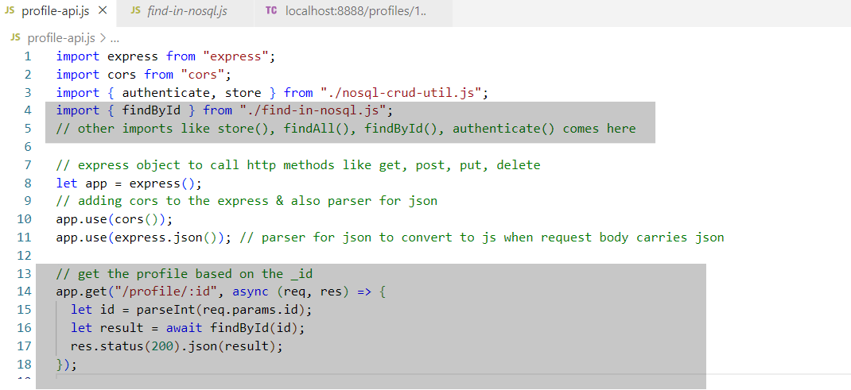
Note: Test this in the thunder-client before checking from the front-end
In the front-end the ProfileSuccess component must pass the _id to the backend and fetch the profile details
Expected Output
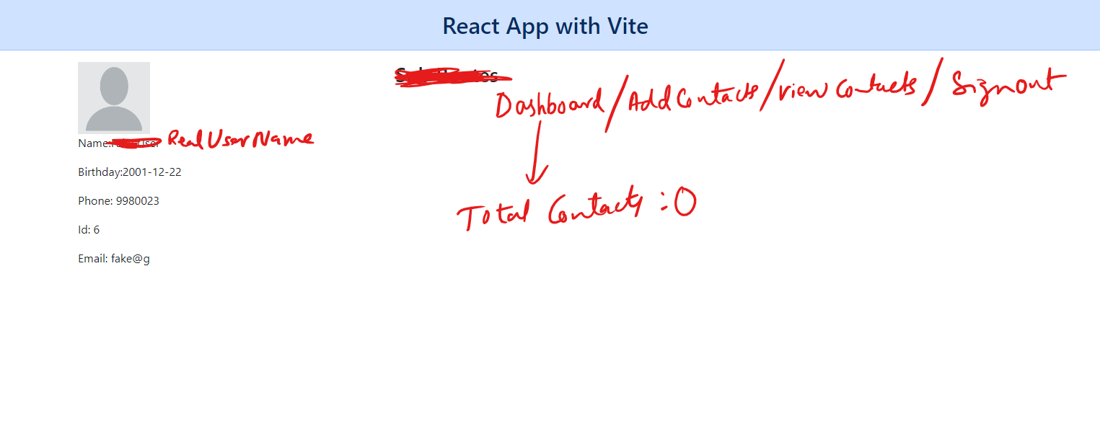
We need to access the backend as soon as the component is loaded, hence we must use a method that is automatically executed when the component is loaded, which is a React hook called useEffect()
useEffect(): This is a react-hook method which is called on following scenarios
- component is re-rendered
- state of the component is modified
Usage: useEffect(callback, [optionalArray])
function Component() {
useEffect(callback, listOfStates);
}
The second parameter used to specify list of states on which the useEffect must be called when it is modified, you can also keep empty.
Import the useEffect from the react library
Invoke the useEffect in the ProfileSuccess component
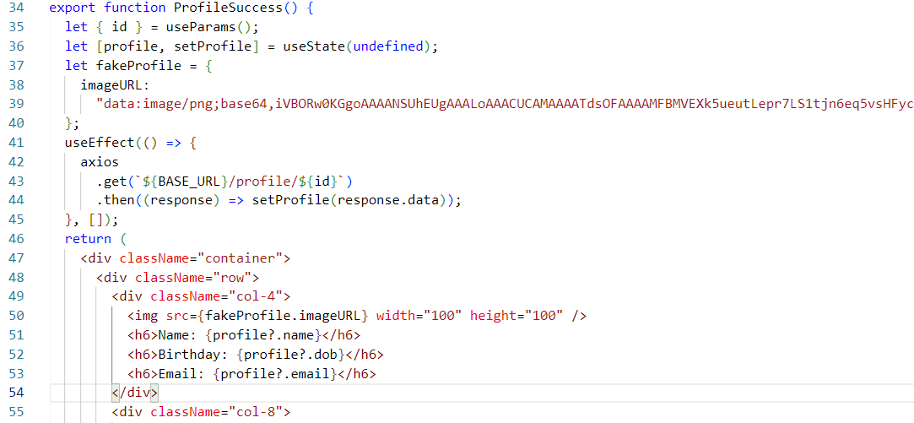
Output:
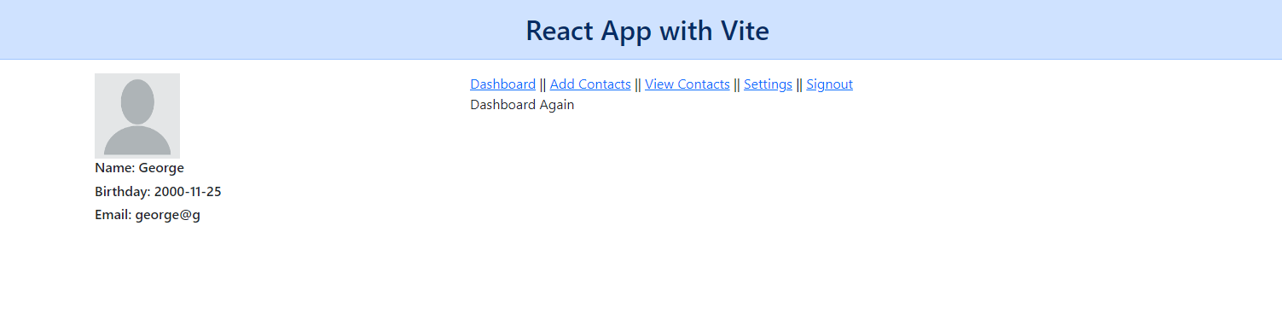
Now you can show the dashboard component
Create a dashboard component that takes the props
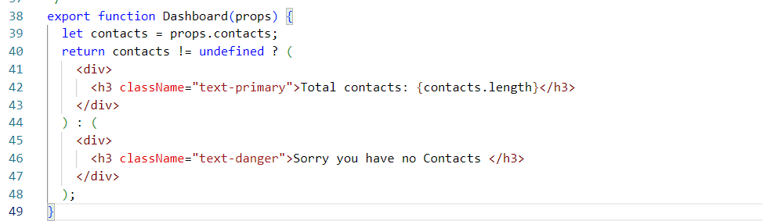
Now in the ProfileSuccess render the dashboard on /dashboard route
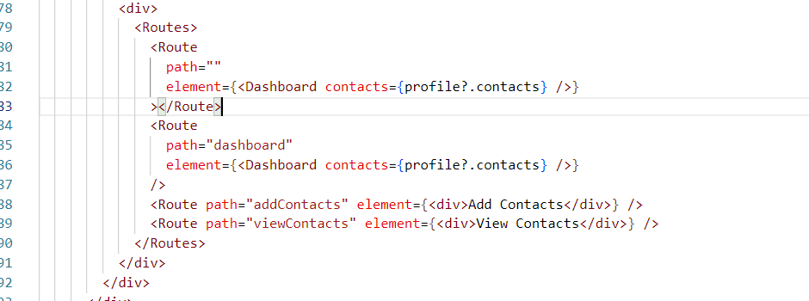
Output:
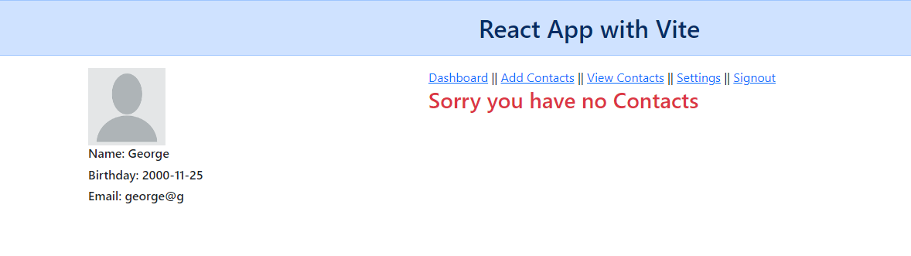
Let us manually add the contacts to the document in the database
you can do that using $push:
db.profile.updateOne({filter}, {$push: {contacts:[{..}, {…}, ..]}})

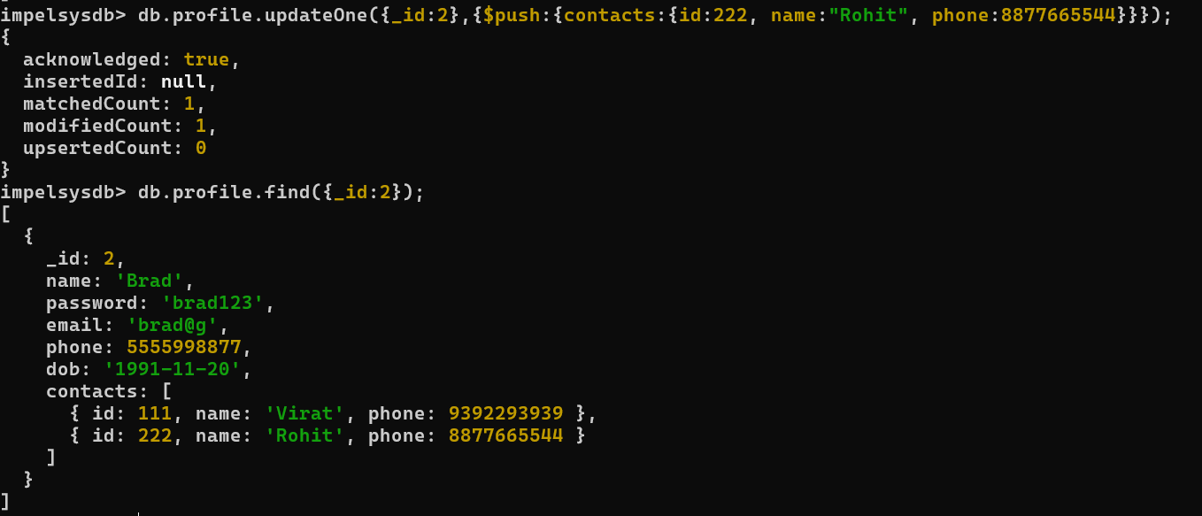

Output:
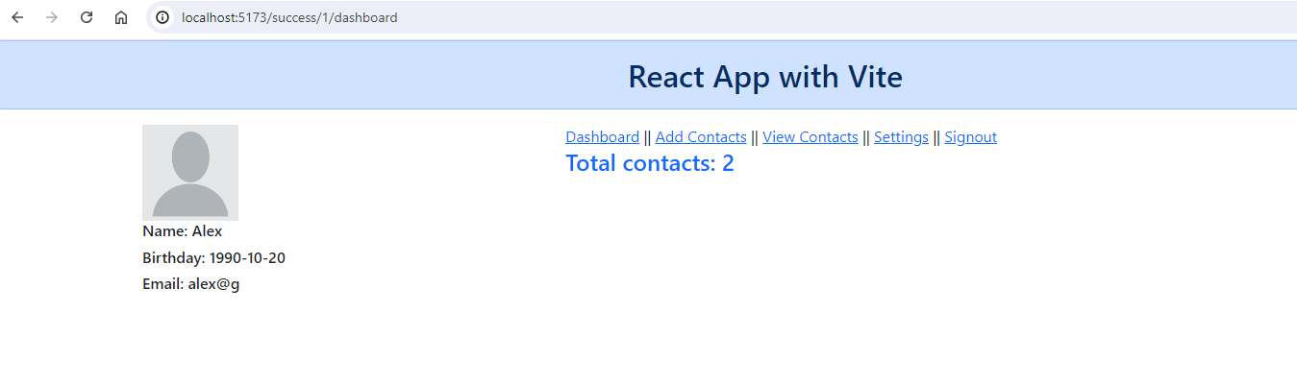
Now ViewContacts component can get the contacts from the ProfileSuccess & render them in the table form, we need to remove the fake contacts
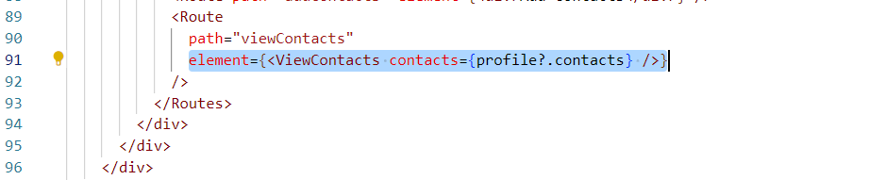
ViewContacts component will render the contacts in a table
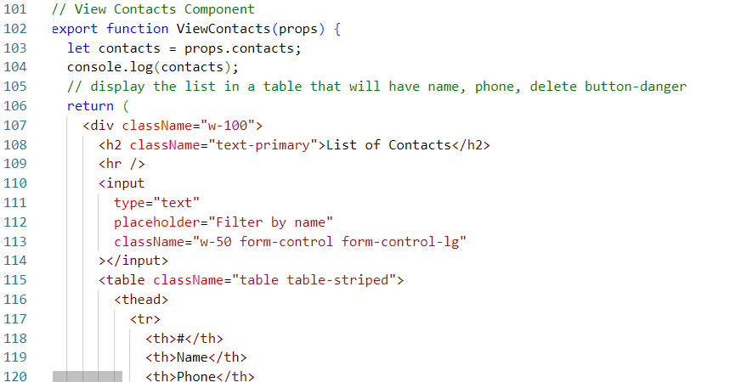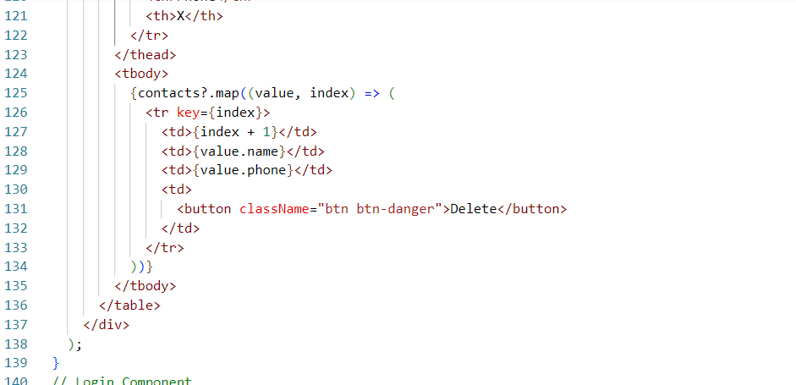

Flux & Redux
They are used to manage the application in a centralized place, instead of using the states in every component you can centralize the states, so that other components within the application will know the changes done to the state
Flux & Redux use the same architecture, but Flux maintains multiple stores whereas Redux maintains a single store
Store: It is a centralized place to maintain the state, Store is usually a javascript object, all the components will have access to this store
Note: All the components subscribes to the store so that they can see the updates done by any components within the application
Redux architecture
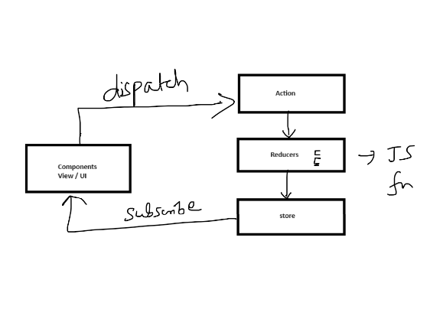
In Redux you will be having following components
- View/UI: These can fire an action i.e., dispatch an Action
- Action: It is a kind of operation or task that needs to be performed
- Reducer: These are Javascript functions which takes various actions & update the store
- Store: This is a Javascript object, which maintains the state of the application, all the components can access this store or get updates from this store because of the subscription
How components will fire an action
useDisaptch(): is the method that will fire an action
How components can read the store or subscribe to the store
useSelector(): is the method components must use to read the updates from the store

How to use Redux in react application
There are two packages you must install
- @reduxjs/toolkit: It includes all the redux core features to build redux applications, it can be used in Vue.js, React.js, Angular or any other JS applications
- react-redux: To use redux in react.

Things to create
- src/reducer/counterSlice.js: JS file that will have reducers which will update the store
- src/app/store.js: JS file that will have global state
- src/components/Counter.jsx: A component that dispatches an action & subscribes to the store
- <Provider store = { … }> This must be wrapped with root component so that store will be available throughout the application

Create a new react project with vite & install the react related libraries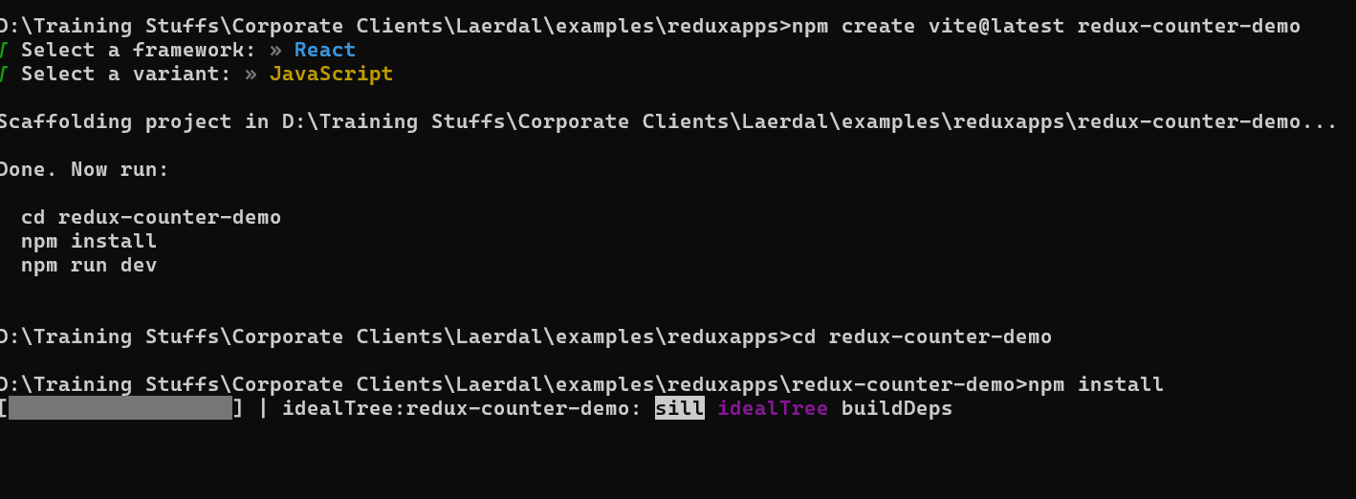
Install @reduxjs/toolkit & react-redux in the same project
We will create a counter program that increases or decreases the counter value
Initial code in App.jsx
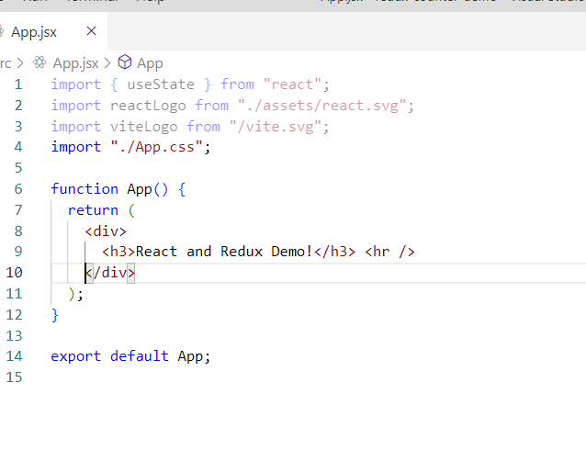
create src/reducer/counterSlice.js
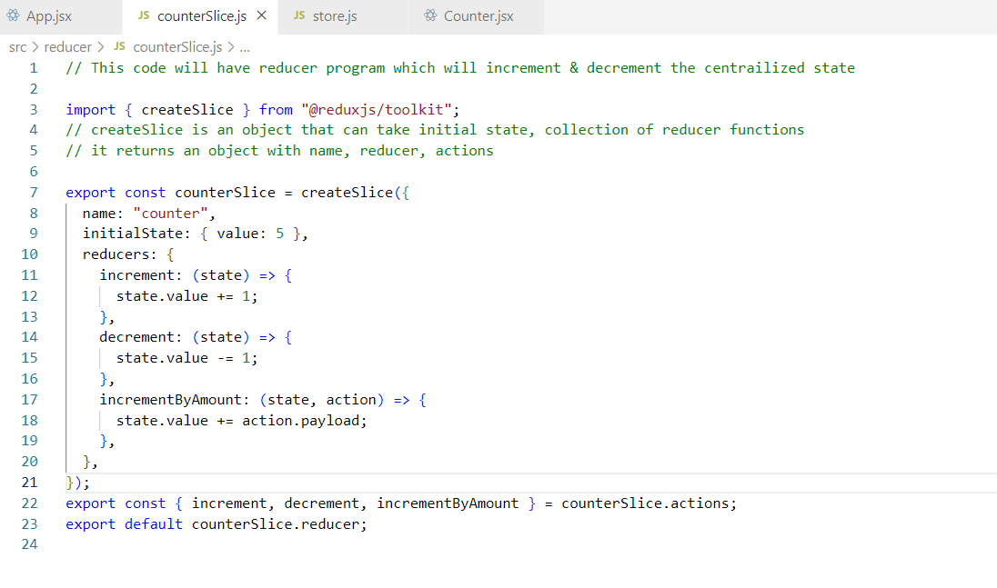
create src/app/store.js
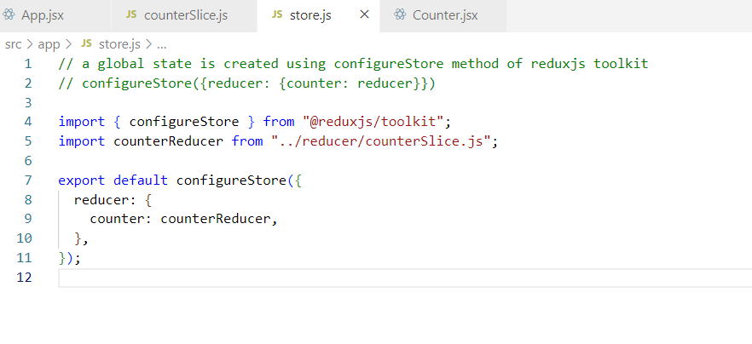
create src/components/Counter.jsx
You must import 2 hook functions from the react-redux
- useSelector(): this is to read the store value which is state.counter.value
- useDispatch(): This will fire an action by using reducer functions like increment(), decrement(), incrementByAmount
i.e., let dispatch = useDispatch();
dispatch( increment() )
dispatch( decrement() )
dispatch( incrementByAmount(20) )

src/components/Counter.jsx
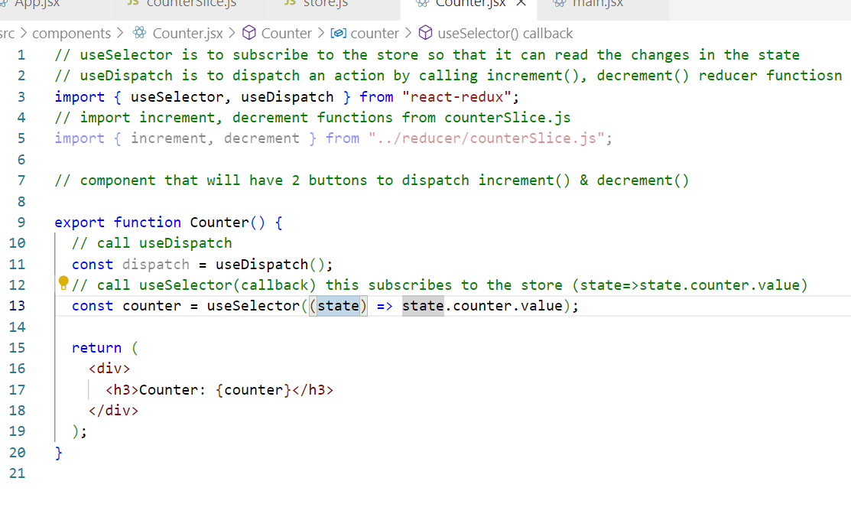
src/main.jsx
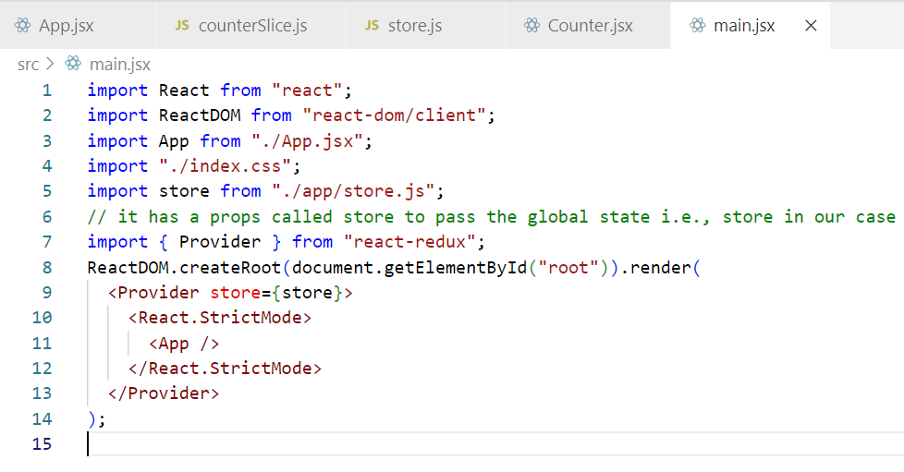
Include the Counter in the root component
src/App.jsx
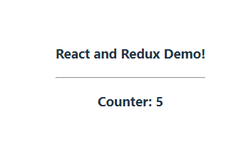
Create 2 buttons in Counter.jsx & fire an action so that it calls the increment() & decrement() of the reducer
Counter.jsx
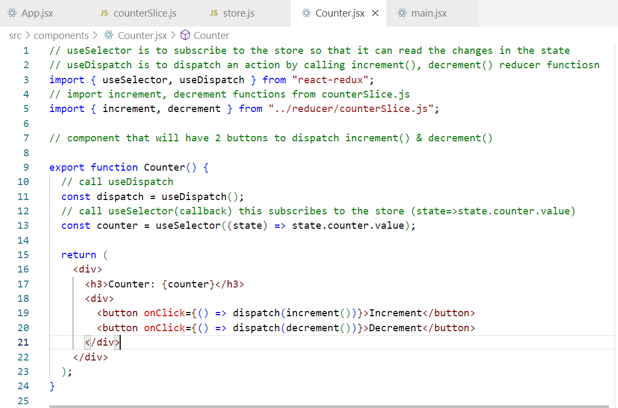
Output:
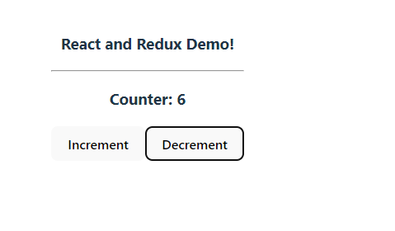
Activity:
Create a separate component which will have an input box that allows user to enter some numbers, beside that create a button that dispatches the action to call incrementByAmount() reducer function present in the counterSlice.js, it must pass the value entered in the input box to the incrementByAmount() function and the counter value that changes must be displayed in this component, display this component below the Counter component itself to observe the global state change.
Solution:
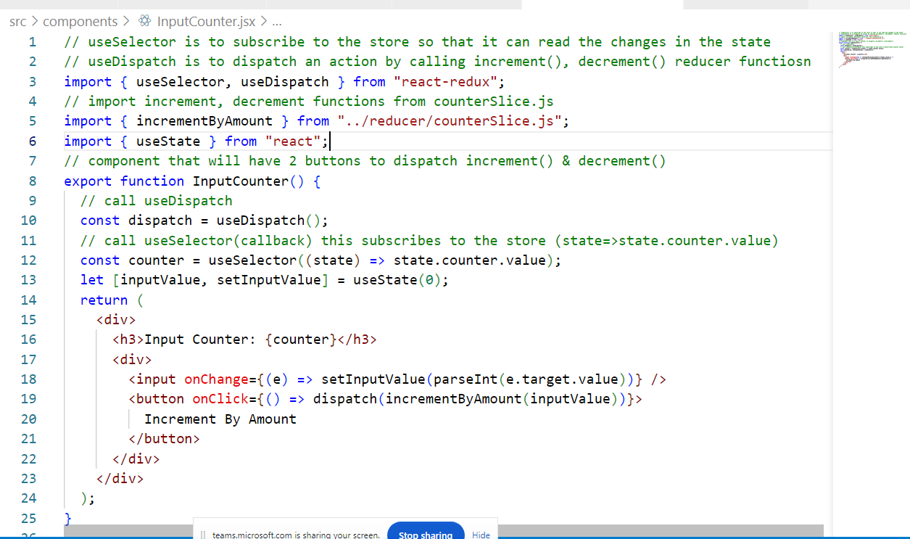
Case Study Activity:
- Implement Add contact so that you could able to enter id[contact-id], name and phone which will be stored in the contacts property of the particular profile
- Implement Settings that will allow the profile to change the password
- In the settings create a button that will have delete profile, so that if you click on this button, it will ask for the confirmation & if yes then it must delete the profile & navigate to the login page.
Note: Implement backend APIs accordingly

Testing in React
Testing the components individually is very important instead of checking manually, because when we check manually we may not able to figure out the minor mistakes, hence its always better to have the test cases, in React you get an inbuilt library called Jest mainly for testing purpose, with Vite this library we don’t get and also to run the test case we must use different commands, even that configuration also wouldn’t be there in the vite, hence its advisable to use npx create to develop react application which comes with test library and commands to run the test cases.
Test files will have .test.js extension, jest will automatically recognize these files
How to run the test cases
npm test is the command to run the test cases.
src/components/Hello.js
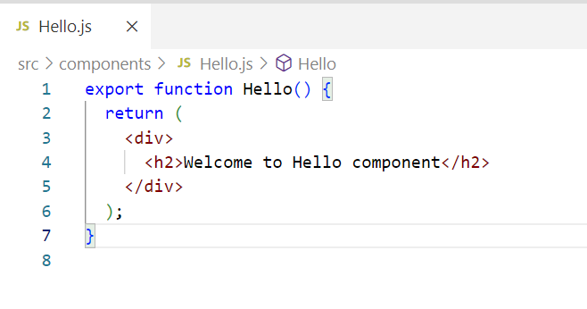
src/components/Hello.test.js
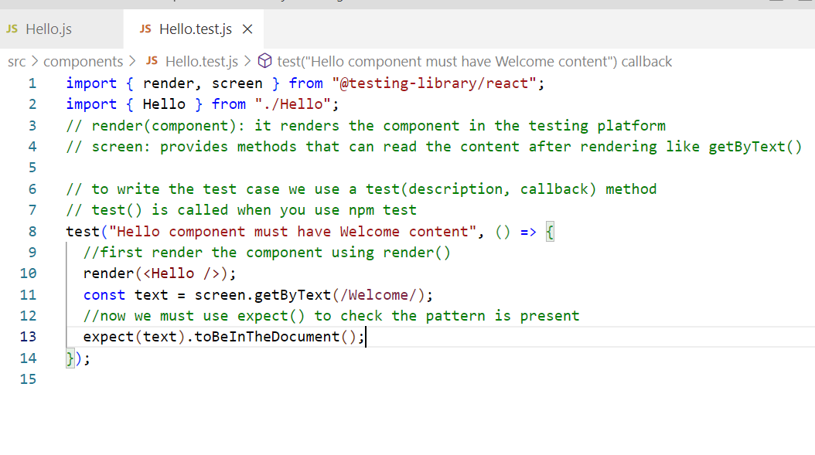
To test we must use npm test command
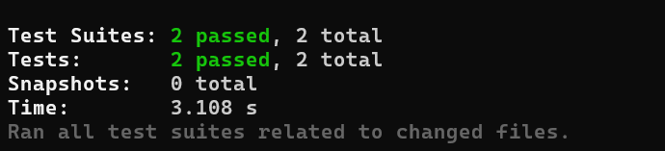
You may get the below warning, you can install the test library in dev dependency to get rid of this

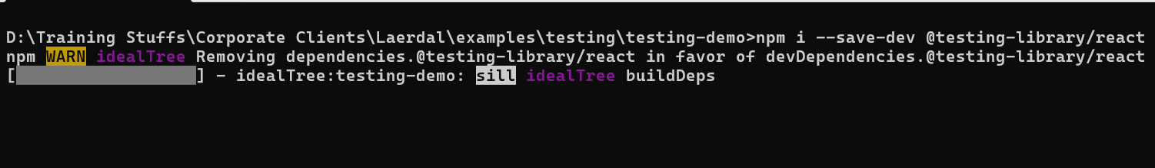
Now again you use npm test, this time you don’t see that warning
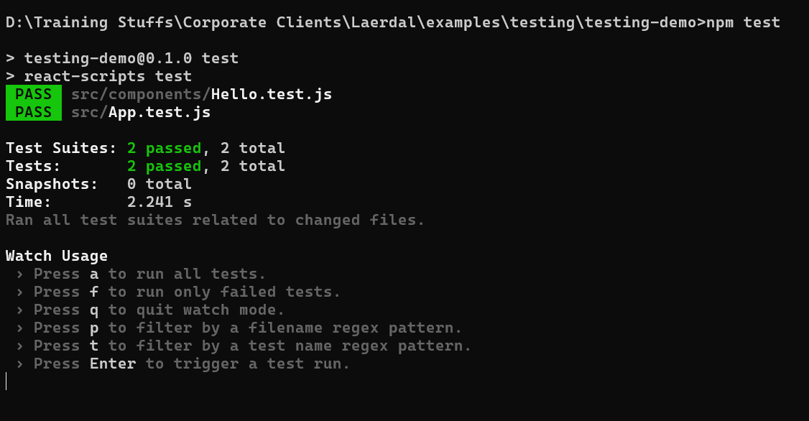
Case insensitive search
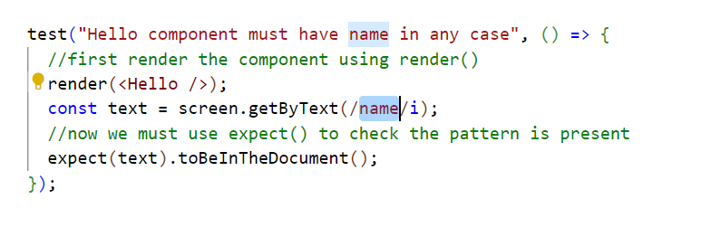
Output:
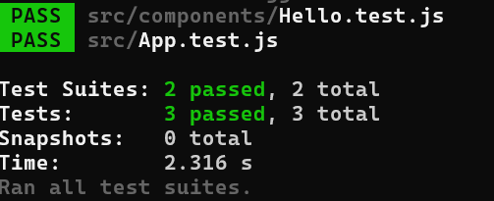

Mock functions:
These are the functions that allow you to test the links between the code by removing the actual implementation of a function, & captures calls to those functions and invokes a different code that gives a mock data.
Mocking services: Services will have business logics, they may hit backend api’s which might be called internally by the components, this backend result may vary time to time, hence we must ensure that our test cases doesn’t fail even when these internal logics result vary, that is done by mock functions, which gives always same data at the time testing by removing the original invocation, this works only at the time testing.
Note: Install axios to make api calls
src/service/users.js
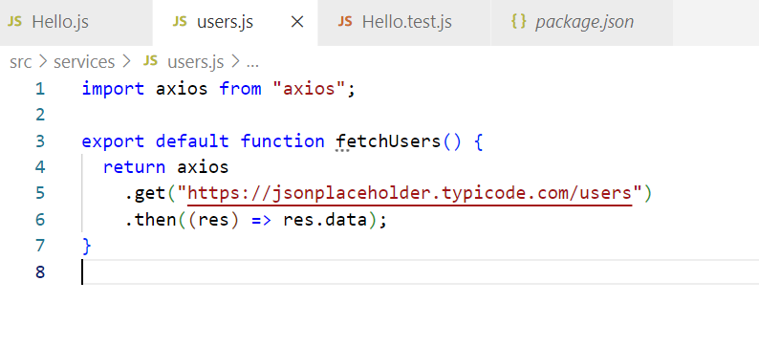
You must use jest.mock(“axios”): this will not hit the backend when there’s axios used
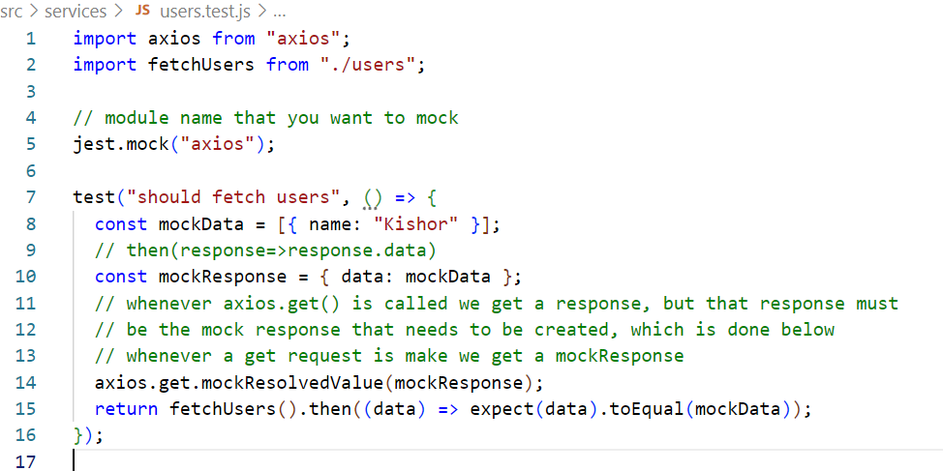
Output:
If you get import error add this in the test command of package.json
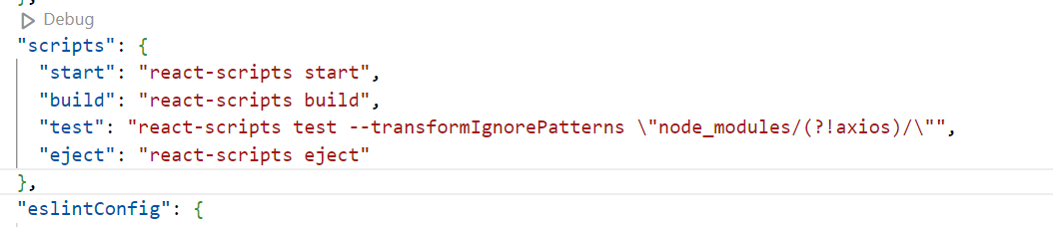
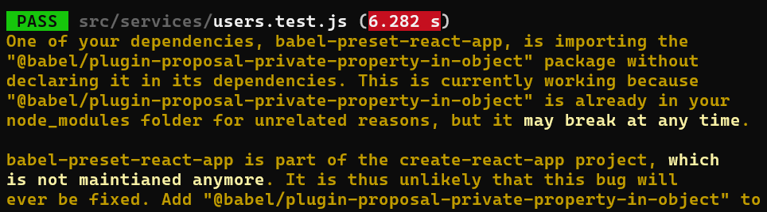

How to build & deploy the react application
You must use npm built command that gives you a build folder which you can deploy in any live server
Note: React allows to quickly test these build files with some test server like serve
Command: npm built
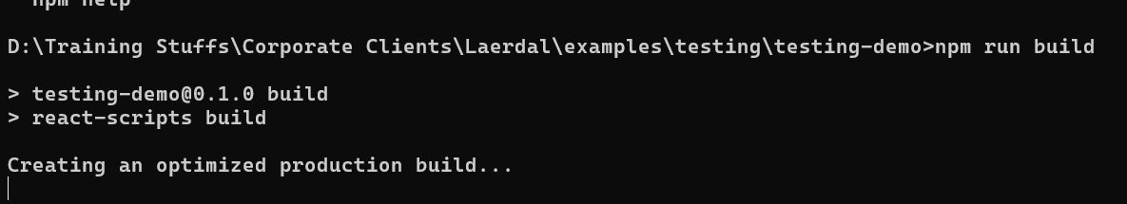
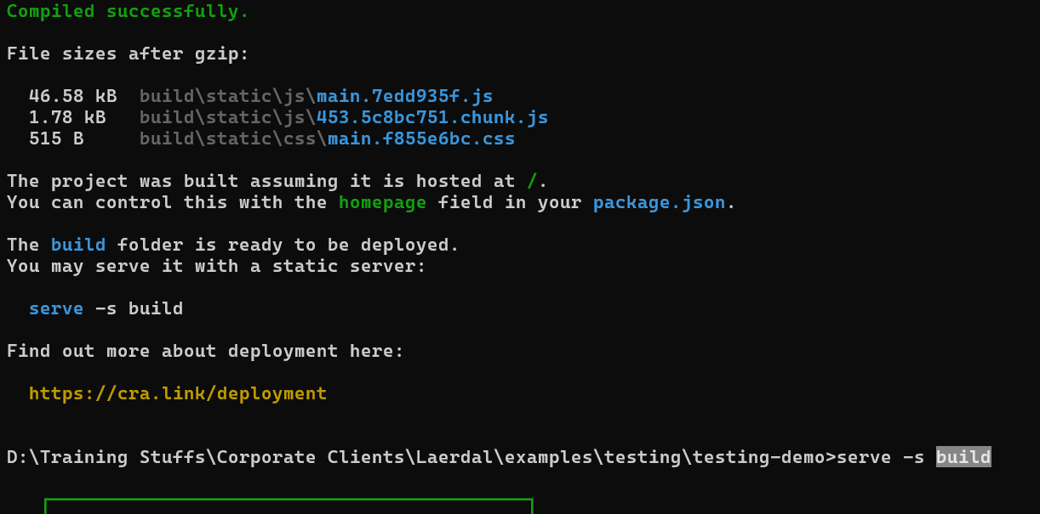

React reference:
https://react.dev/
Node reference
https://nodejs.org/en/learn/getting-started/introduction-to-nodejs
Mongodb reference
https://www.mongodb.com/docs/manual/

